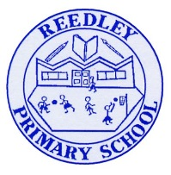
Year 4 Homework – The Sea Serpents and The Horrendous Hydras.

Date homework set: Thursday 18th March 2020
To be returned to school by: Monday 22nd March 2020

Talking Topic
Talk to a family member or friend about how to prevent germs from spreading. What can you do to ensure that we stay healthy? How long should we wash hands for? What methods should be used?
Tick when you have completed this task.

Maths
Practice your times tables on Time Tables Rockstars or ask for a paper copy.
https://play.ttrockstars.com/auth/school/student/

Log onto My Maths and complete the tasks I have set for you.
https://www.mymaths.co.uk/primary.html

Tick when you have completed this task.
Reading
WRITE THESE IN YOUR READING JOURNAL AND GET PARENTS TO SIGN
Read to an adult or an older sibling at least 3 times a week for 10-15 minutes. Get your reading record signed. We will be checking.

Complete your reading for pleasure.

Tick when you have completed this task.

Spellings
Practice the spelling of these 5 words using the methods we have learnt in No Nonsense Spelling.
Reign, island, interest, natural, probably
Write a sentence including each of these words, making sure they make sense.
Tick when you have completed this task.

Writing
Write a short Non Chronological report on an animal of your choice.

Tick when you have completed this task.
Theme
Draw and label the flags of countries that are in Europe.
Tick when you have completed this task.

