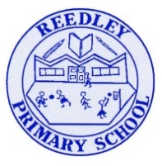
Spelling Bee – Reedley Primary School

Year 1

Word | Look | Say | Cover | Write | Check
are
break
cold
eye
great
today
grass
some
would
even
half
money
friend
your
know
prove
school
parents
whole
plant
should
where
fast
behind
come
Christmas
hour
once

