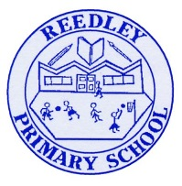
Year 4 Homework – The Sea Serpents and The Horrendous Hydras

Date homework set: Thursday 10th June 2021
To be returned to school by: Monday 14th June 2021

Talking Topic
Talk to a family member or a friend about French day and what we learnt about.

Tick when you have completed this task.
Maths
Practice your times tables on Time Tables Rockstars or ask for a paper copy.
https://play.ttrockstars.com/auth/school/student/

Log onto My Maths and complete the tasks I have set for you.
https://www.mymaths.co.uk/primary.html

Tick when you have completed this task.
Reading
WRITE THESE IN YOUR READING JOURNAL AND GET PARENTS TO SIGN
Read to an adult or an older sibling at least 3 times a week for 10-15 minutes. Get your reading record signed. We will be checking.

Complete your reading for pleasure.

Tick when you have completed this task.

Spellings
Practice the spelling of these 5 words using the methods we have learnt in No Nonsense Spelling.
Group, pressure, early, strange, actual
Write a sentence including each of these words, making sure they make sense.
Tick when you have completed this task.

Writing
Write a news paper report. You can choose what you are reporting on.

Tick when you have completed this task.
Theme
Following on from your art lesson this week, have a go at drawing one of Vincent Van Gogh’s pieces of art work.
Tick when you have completed this task.

