Friday 10th March 2023
Good morning boys and girls I would like you to think back to my story ‘Supertato’ where I rescue the vegetables from the Evil Pea and answer the following questions. Good luck and KERPOW!
KL – To make simple inferences
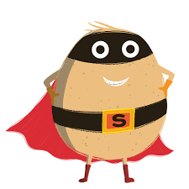
How is Supertato feeling?
__________________________________________
__________________________________________
__________________________________________

What is Supertato thinking?
__________________________________________
__________________________________________
__________________________________________

What might Supertato say?

_________________________________________
_________________________________________
_________________________________________

Link to the story on youtube
SUPERTATO - AUDIO BOOK WITH PICTURES - YouTube

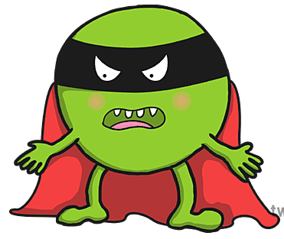
Good morning boys and girls I am out of the freezer again! Can you think back to when I was committing terrible crimes against the vegetables and answer the following questions.

How is Evil Pea feeling?
__________________________________________
__________________________________________
__________________________________________

What is Evil Pea thinking?
__________________________________________
__________________________________________
__________________________________________

What might Evil Pea say?

_________________________________________
_________________________________________
_________________________________________

