**Friday 10th March 2023**

**KL: To be able to identify and label basic parts of a plant.**

flower

leaf

roots

fruit

stem

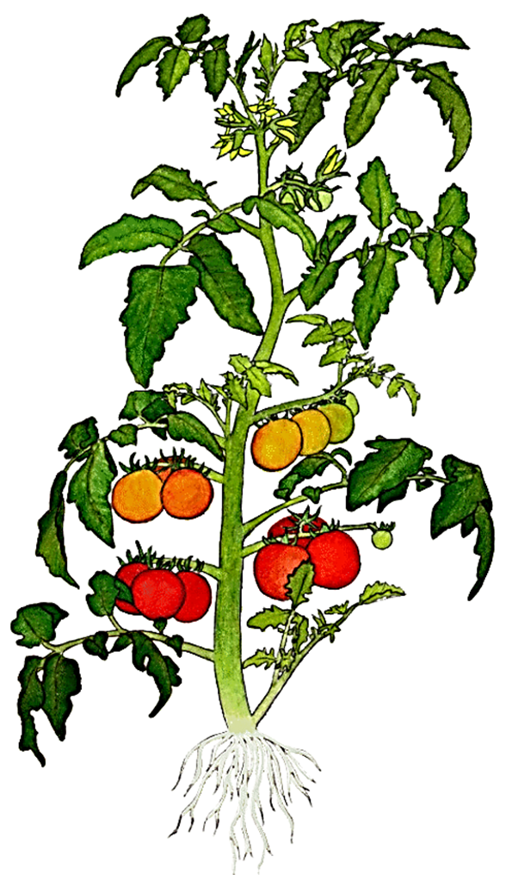

**Friday 10th March 2023**

**KL: To be able to identify and label basic parts of a plant.**

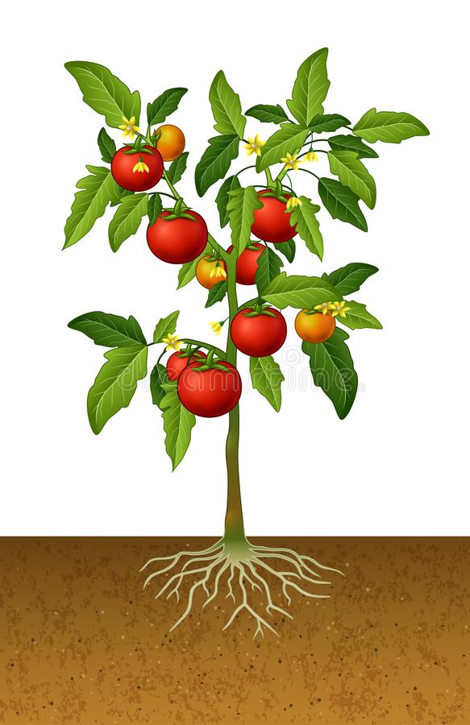

**Try this:**

**Write a sentence about what each part of the plant does.**

E.g. *The petals are brightly coloured to attract bees and butterflies to their pollen.*