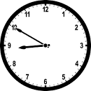
Friday, 17 March 2023
Dear Parents/Carers,

Attendance
Our overall attendance for last week is 90.58%.
This is still lower than our target of 96%.

If your child is too unwell to come to school, please ensure that you call school to let us know the reason. You can speak to us directly, or leave a message. Call the school number and press Option 1.

Punctuality
We had 4 hours and 27 minutes of lates last week, meaning vital learning is still being missed by some children.
Please ensure that your child is in school before the gates closes at 8.50am each day.

Ramadan
I would like to wish a happy Ramadan to all of our Muslim families.

Fasting During Ramadan
There is no requirement for primary-aged children to fast, although I understand that this is a special time and some families choose for their older children to do so. If you make the choice with your child that they will take part in the fast, please ensure that they are physically able to cope with demands that fasting places on them. Children are expected to take a full and active part in all aspects of the school curriculum during Ramadan . If they are not able to do so, we will discuss the matter with you.

Letters have been made available to the older children today, for those children who may intend to fast during Ramadan. Further details are on the letter, including arrangements for those children during the lunchtime. If you would like your child to fast, please ensure that you complete the letter and return it to school on Monday. If you haven’t received a letter, please contact Mrs Iqbal, and she will send a letter to you.

Comic Relief
Well done to the School Council for organising the fundraising event for Comic Relief. They spoke to some of the children in assembly on Monday about the reasons that we have been fundraising today.

Times Tables
Good luck to the children who will be attending the Times Table Competition on Wednesday.

Online Safety
This week I have attached information about TikTok.
- Some of our children are accessing TikTok at home and this is often unsupervised.
- The minimum age for using TikTok is 13 years old.
- This is due to some content which contain adult themes.
- I would highly recommend that you ensure that your children cannot access this, and other websites or age-restricted APPs. All devices should have parental controls. I would also recommend that you regularly check your child’s search history on all devices.

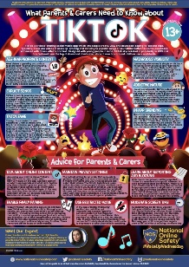

Thank you for your support,
Mrs Sarah Bell
Headteacher

