Vocabulary |  |  |  | Facts about teeth and digestion
Canine | Your four canine teeth sit next to the incisors. You have two canines on the top of your mouth and two on the bottom.  Canines have a sharp, pointy surface for tearing food. | Intestines | The intestines are like a hollow tube so that food and bile from the stomach can reach the small intestine and large intestine. | . The enamel on the top surface on your tooth is the hardest part of your entire body.  . Teeth start to form even before you are born—milk teeth or baby teeth start to form when the baby is in the womb, but they come through when the child is between 6-12 months old.  . Humans use four different types of teeth (incisors, canine, premolars, and molars) to cut, tear and grind their food.  . Humans have only two sets of teeth in their entire lifetime—baby teeth and permanent teeth. Once you have your permanent teeth, make sure you take good care of them.  . No two people have the same set of teeth—your teeth are as unique as your fingerprint, so be proud of your unique set of teeth.  . Your mouth produces over 25,000 quarts of saliva in a lifetime—that’s enough to fill two swimming pools. Saliva has many uses, including assisting you with your digestion and protects your teeth from bacteria in your mouth.  . The muscles in your esophagus act like a giant wave. That is what moves food or drinks down to your stomach. This wave action is called peristalsis.  . The second part of your small intestine is called the jejunum. That’s just fun to say!  . Enzymes in your digestive system are what separate food into the different nutrients that your body needs.
 |  | Oesophagus | Is the part of the gastrointestinal system between the mouth and the stomach.
Molar | Molars are your biggest and strongest teeth. The large surface area of your molars helps them grind up food.
 |  | Saliva | Saliva is the watery substance made in the mouths of humans and many animals.
Incisor | A narrow-edged tooth at the front of the mouth, adapted for cutting. In humans there are four incisors in each jaw.
 |  | Stomach | It holds food after ingestion. Food in the stomach then passes through to the small intestine where most of the food's nutrition is absorbed.
Pre-molar | A tooth situated between the canine and the molar teeth. An adult human normally has eight, two in each jaw on each side.
 |  | 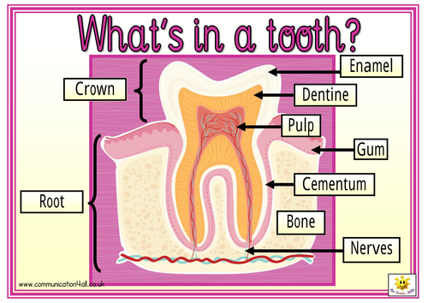
Plaque | A sticky deposit on teeth in which bacteria proliferate.
Digestive System | The digestive system is the parts of the body that digest food; it is also called the gastrointestinal system. It breaks down food into simple chemicals that can be absorbed into the blood stream.
The Digestive System
