**Science Vocabulary**

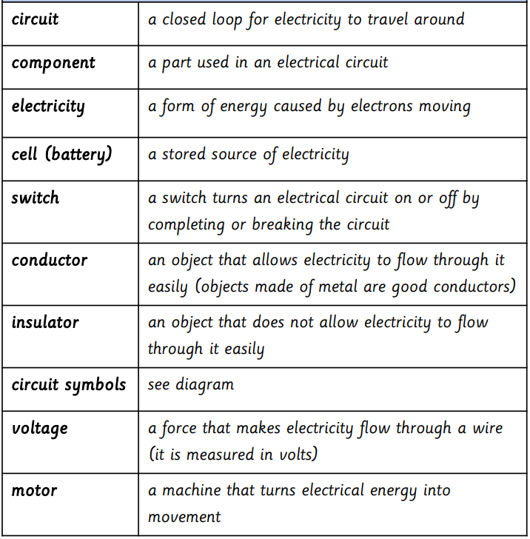

**Design and Technology**

|  |  |
| --- | --- |
| View | Seeing, looking or observing |
| Reflection | The image of something in a mirror or on any reflective surface |
| Bounces light | light that is bounced off a reflective surface onto the subject |
| Periscopes | Viewing apparatus |

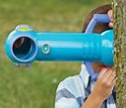 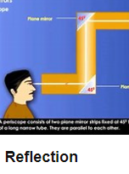 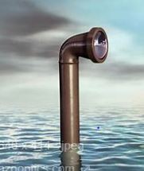

**Geography**

|  |  |
| --- | --- |
| Geography Vocabulary |  |
| urbanisation | Means belonging to or relating to a city or town. |
| Motorway | A British main road for fast moving traffic |
| Canals | A long, thin stretch of water that is artificially made either for boats to travel along or for taking water from one area to another |
| Agriculture | Cultivating land and rearing crops, livestock and farming; |

