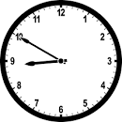
Monday, 27 March 2023
Dear Parents/Carers,

Attendance
Our overall attendance for last week is 92.80%.
This is still lower than our target of 96% but was an improvement on the week before.

If your child is too unwell to come to school, please ensure that you call school to let us know the reason.
You can speak to us directly, or leave a message. Call the school number and press Option 1.

Punctuality
We had 6 hours and 56 minutes of lates last week, meaning vital learning is still being missed by some children.
Please ensure that your child is in school before the gates closes at 8.50am each day.

Ramadan
I would like to wish a happy Ramadan to all of our Muslim families.

Ofsted
As you know, we had our routine Ofsted inspection last week, where three inspectors came to judge the quality of education at our school. Thank you to everyone who contributed to the parental questionnaire or spoke to the inspectors.
We can’t release the judgement until the final report comes out next month, but I can say that I feel the report will give an accurate picture of Reedley School. The inspectors did raise a number of concerns about pupil attendance, in particular the number of days that have been lost to children taking leave of absence.

Spelling Bee
The Spelling Bee semi-final takes place on Tuesday at Walverden School
Yr 1 - Ali Shair
Yr 2 - Yousaf Sajjad
Yr 3 - Juwayriya Ashraf
Yr 4 - Zainab Ahmed
Yr 5 - Sabeeh Hassan
Yr 6 - Yahya Atif

Times Tables
Unfortunately the times table competition had to be postponed as, due to the Ofsted inspection, I was unavailable to host the event. We will be looking for another date after Easter.

Events last Week
A group of Y3/4 boys attended a football tournament on Thursday and a group of children also attended a tri-golf competition.

Parent/teacher Meetings
Some of the meetings were postponed last week, due to our inspection.
The following meetings have been rescheduled for this week.
Rec – Tuesday morning and after school
Y1 and Y2 – Tuesday afternoon and after school
Y3 and Y4 – Wednesday afternoon and after school
The appointment times will be the same as the ones that were booked for last week.

Online Safety
This week I have attached a guide about using secure passwords.
Allegedly, around 100 accounts each second are broken into.
The advice includes information recommending different passwords for different accounts and that the longer ones are safest.

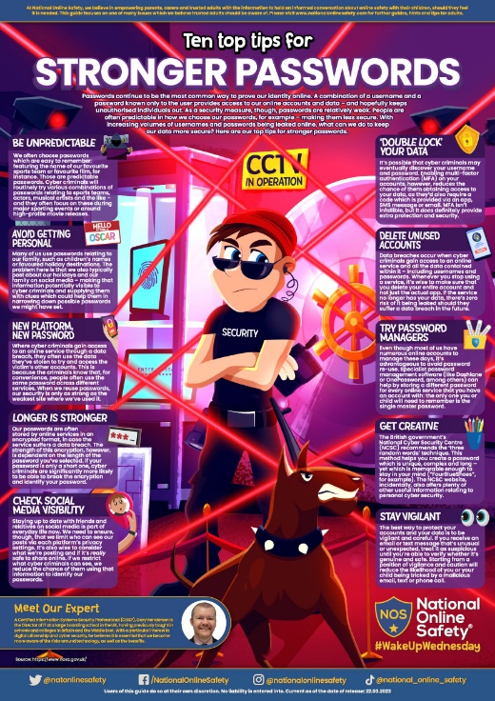
Thank you for your support,
Mrs Sarah Bell
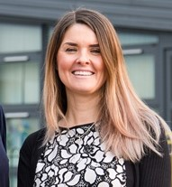
Headteacher

