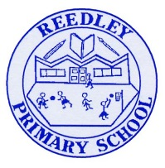
Year 1 Homework
Date homework set: Thursday 11th May 2022
To be returned to school by: Tuesday 16th May 2022

Talking Topic
This week during our topic ‘The Great Fire of London’ we have researched what fire fighters and fire engines looked like in 1666 and now. Please talk to your child about what fire fighters wore then and now. Compare fire engines from 1666 and fire engines that are used now. How are they the same and how are they different?
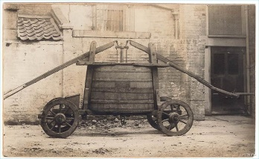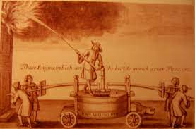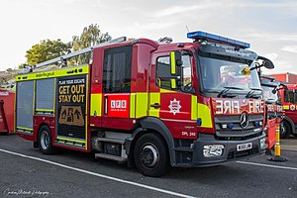

Maths
This week in Maths children have been using the mathematical equipment to represent numbers to 20. We have recapped our number bonds to 10 and have progressed to our number bonds to 20. Please work with your child to remember some of the number bonds to 20.

20+0=20 0+20=20 19+1=20 1+19=20 18+2=20 2+18=20 17+3=20 3+17=20 16+4=20 4+16=20 etc

Reading
Your child will be bringing their reading books home on Friday. Read your reading book and get an adult to sign the monkey book. Books will only be changed on Friday’s if they are signed. Please ensure reading books are in school everyday so that they can also be listened to in school.
Please also log onto bug club and encourage your child to read and complete the task at least once a week. (password is stuck in the front of this book)
Reading for pleasure bookmarks- Your child’s bookmark is stuck in the back of this homework book. Please complete 3 of the activities each week in the back of the homework book. Once these are completed to a high standard your child will receive a certificate.
Spellings
Please practise these spellings : eleven, twelve, thirteen, fourteen, fifteen,
Writing
We have been learning about Samuel Pepys and how he kept a diary during The Great Fire of London. In his diary he wrote about key events that took place during the fire and his personal accounts too. Ask your child to write a diary entry explaining a day in their life. Write about what has happened or what you have done that day. Start with: Dear diary today I have ……’

