Monday, 11th September 2023
Dear Parents/Carers,

Welcome back everyone. It has been lovely to see everyone again this week. I have loved hearing about the children’s summer holidays and also heard that some of our past pupils achieved excellent GCSE grades.
A special welcome to our new families who have joined Reedley for the first time. We hope that your children will be very happy at Reedley.

Punctuality
We had 2 hours and 20 minutes of lates this week, meaning vital learning is still being missed by some children. Please ensure that your child is in school before the gates closes at 8.50am each day.

Attendance
Our overall attendance for this week is 94.7%.
This is below our target of 96%.

StudyBugs
Please make sure that you have made a Studybugs account and that you use this to inform us of your child’s absence. You can download this as an APP on your phone. When you are reporting a child’s absence, please ensure that you inform us of the nature of your child’s illness.

Events This Week
Our Year 2 children took part in a walk around the local area, as part of their geography topic.

Upcoming Events
- Year 5 Trip
Mrs Hardman’s class are going to Clitheroe Museum on 19th September Mrs Boyd’s class are going to Clitheroe Museum on 20th September.

- Year 4 Swimming
Children in Year 4 will have swimming lessons this year. Mrs Phillip’s class will start on Monday 18th September. Miss Radcliffe’s class will start their lessons on 30th October 2023.

- Year 1 Trip to the Church
Year 1 children will be taking a trip to the local church towards the end of September, as part of their RE topic.

Children Starting School in September 2024
If your child was born between 1 Sep 2019 - 31 Aug 2020 then they will start school in September 2024. You will need to apply for a school place online at https://www.lancashire.gov.uk/children-educationfamilies/schools/apply-for-a-school-place/starting-primary-school/ Applications are open now and close in January 2024.
If you, or anyone you know, has a child that will be starting school in 2024, please call Mrs Iqbal to arrange a time to come and have a look around.

Clubs
 | Who is it for? | What is the club? | How much is it? | How do we book?
Monday | Y1 & Y2 | Ultimate Frisbee | Free | Course full
Wednesday | Y3 & Y4 | Archery | Free | Course full
Thursday | Y3, Y4, Y5, Y6 | Mad Science | £60 for 6 weeks | Book and pay online https://northengland.madscience.org/parents-registera.aspx?action=search&org=41683#ctn-activitylist (Search for Reedley School under ALL LOCATIONS)
Thursday | Y5 & Y6 | Archery | Free | Course full

A small selection of clubs start next week. If you booked a place before the holidays then you will get a message from school reminding you.
Please note that the clubs finish at 4.30pm, which is later than the usual club time.
We cannot accept any more participants on the Frisbee and Archery courses but you may still be able to apply for the Science club.
The Coding club that we advertised will not be running, due to not enough interest.

Concerns
Don’t forget that if you have any concerns about your child, you can book an appointment to meet/chat with their class teacher. If you need feel the need to, you can also meet with your child’s Phase Leader, who are all senior members of staff. Please call the school office to book any appointments. Alternatively, you can approach the staff members on the playground after school, and if they can’t meet you on that day, they will arrange a mutually convenient time.

Year Group | Phase Leader
Reception | Miss MacKenzie (on maternity leave until the end of September – please call the school office if you have any issues)
Year 1 and Year 2 | Mrs Collins
Year 3 and Year 4 | Miss Radcliffe
Year 5 and Year 6 | Mrs Hornby

Key Dates
- School will be closed for half term from Monday 23rd October to Friday 27th October.
- Week beginning 16th October - Design and Technology week. Parents/carers will be invited to come into their child’s class at a designated time
- Week beginning 16th October - Parents/Carers can meet teachers this week for an update on their child’s progress
- Week beginning 30th October. Art week. Parents/carers will be invited to come into their child’s class at a designated time

Online Safety Guide
I have attached a guide for parents/carers about TikTok and the risks that it poses for children.
You should be aware that TikTok is not suitable for children under the age of 13 and therefore none of our pupils should be accessing this. We advise that you ensure that you have parental settings activated on all devices.

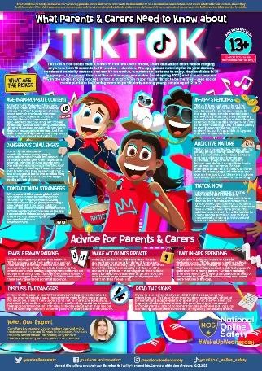
Thank you for your support,

Mrs Sarah Bell
Headteacher

