Year 5 Homework

Date homework set: 12.9.19
To be returned to school by: 17.9.18

Talking Topic
- To discuss the following topic:
“Why I must learn my times tables?”

Tick when you have completed this task.
Maths
- Learn the 9 times table
- On My Maths, complete Year 5 – place value- Counting 5
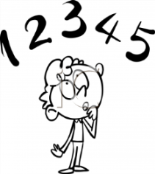
Tick when you have completed these tasks.
Reading
- Read the next chapter from your new reading for pleasure book.
- Complete your book- mark.
- Read your book on Bug Club and write the book in you reading diary.
Tick when you have completed this task.

Spelling
Learn this week’s spellings.
doubt
solemn
thumb
whistle
Tick when you have completed this task.

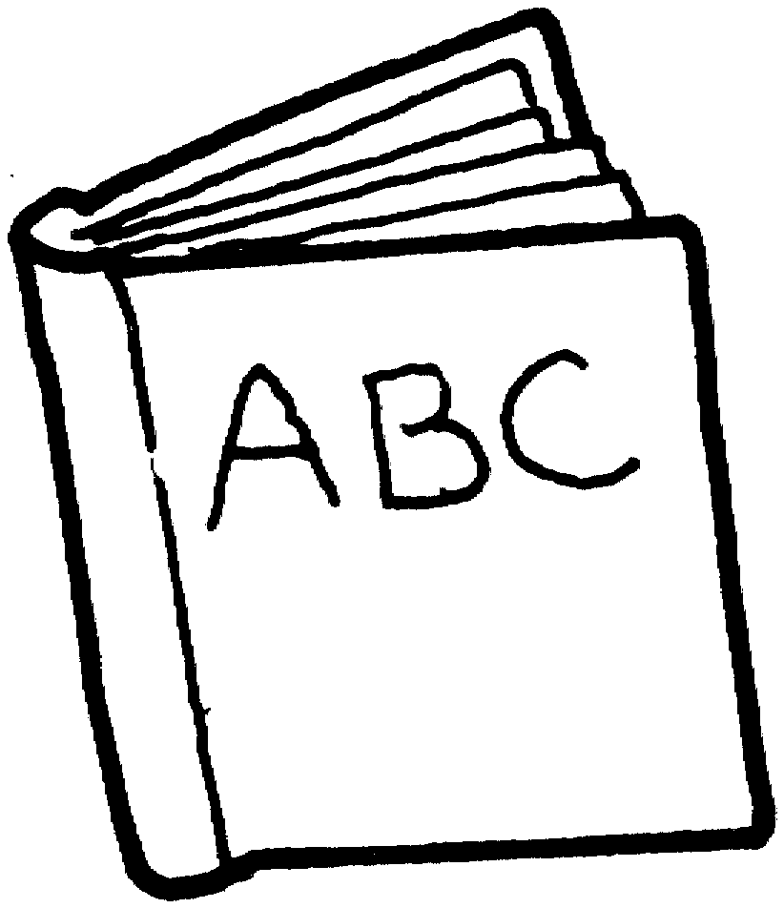
Spag.
Complete the activity below.
Complete the SAG activity on SPAG.COM.
Write the acivity you completed below.

Writing
- Write a persuasive paragraph about why we should use neat handwriting..
Key Skill: Modal verbs and noun phrases.
Tick when you have completed this task.

