Year 4 Homework – Starling Class and Kingfisher Class
Date homework set: Thursday 14th September 23
To be returned to school by: Tuesday 19th September 23

Talking Topic (10 min)
Talk to a family member or a friend about our value this week ‘resilience’. What does it mean? Discuss a time you have been resilient at school or at home.
Tick when you have completed this task.
Maths (10 min)
This year, Year 4 children will be taking part in the Multiplcation Maths Check. Therefore, we would like them to practice their times tables as much as possible so that they are confident when the check comes around.
Please use the link below to practice as it is a similar format to the one used during the formal check.
MTC Test - URBrainy
If you need paper copies to practice times tables please ask your class teacher.
Tick when you have completed this task.

We have been looking at rounding to the nearest 10,100 and 1000 this week. Have a go with these – you can work them out in your homework book.
- Round to the numbers to the nearest 10
- Round the numbers to the nearest 100
- Round the numbers to the nearest 1000

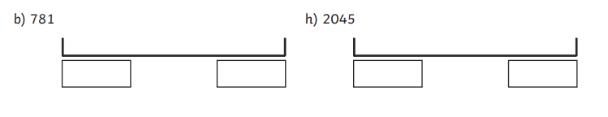

Tick when you have completed this task.

English (10 min)
Write a prediction explaining what you think Mount Merapi is going to be like – remember the Fire-Fiend (Razvani) lives there! Think about if it is going to be a place full of danger or a place full of lovely things.

I think…… will happen……..because in the text it suggests………..
Tick when you have completed this task.

Other tasks that could be completed;
. Practice Year 3/4 spellings.
. Times Tables Rockstar’s
. Purple Mash
. My Maths
. Read your reading book or Reading for Pleasure book.
. Complete the reading for pleasure book marks.
. Spag.com
. Bug Club

