Year 5 Homework

Date homework set: 19.9.19
To be returned to school by: 24.9.19

Talking Topic
- To discuss the following topic:
“Who is our present prime minister?”

Tick when you have completed this task.
Maths
- Start times table rock stars
- On My Maths, complete Year 5 – Number and Place Value- counting 5.
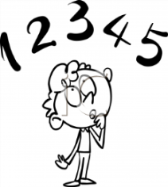
Tick when you have completed these tasks.
Reading
- Read the next chapter from your new reading for pleasure book.
- Complete your next bookmark.
- Complete the book on Bug Club.
Tick when you have completed this task.

Spelling
Learn this week’s spellings.
Who
What
Where
When
Which
With
Accommodate
Accompany
accordingTick when you have completed this task.

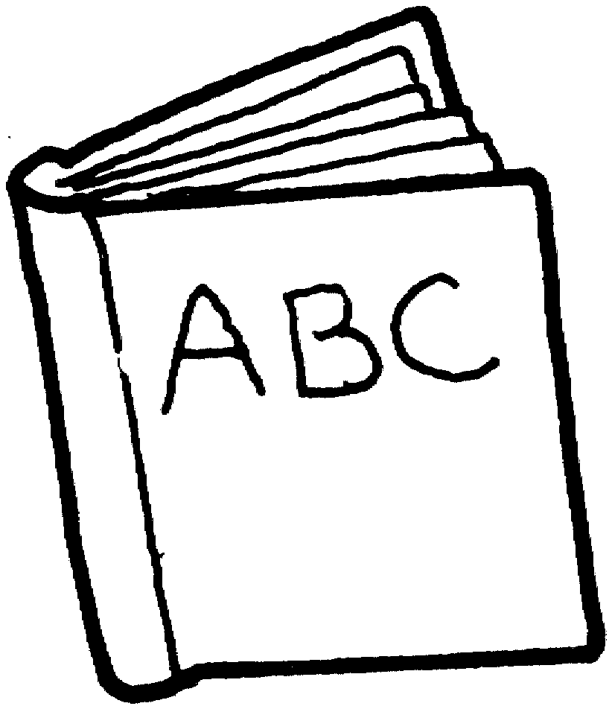
Spag.
Complete the activity- grammar on SPAG. Com.

Writing
- I want you to write a sentence for each of this week’s spellings. Remember to make sure each sentence makes sense.
Tick when you have completed this task.

