Friday, 22 September 2023
Dear Parents/Carers,
Punctuality
We had 5 hours and 30 minutes of lates this week, meaning vital learning is still being missed by some children.
Please ensure that your child is in school before the gates closes at 8.50am each day.

Attendance
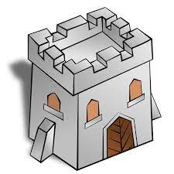
Our overall attendance for this week is 93.74%. Please use the Studybugs app to notify school if your child is poorly.

Events This Week
- Our Year 5 children had a wonderful trip to Clitheroe Castle and Museum this week.

- Two children from Year 5 attended training on Thursday, learning all about how to help children with Mental Health and motivation issues.

- Some of our Y5/6 boys took part in a football tournament on Monday at Fisher More High School. They had to battle the wind and rain throughout!

- Some of our Y4 children took part in a multiskills event at Colne Sport’s Centre

- Reading Buddies – a number of our Year 5 and Year 6 children have been appointed as Reading Buddies. They will support younger children with reading skills.

Upcoming Events
- Year 1 are having a trip to St Luke’s Church on Monday.
- Year 2 are having a visitor on Tuesday.

Parking
A number of drivers are stopping on the yellow zig-zag or the single or double yellow lines when dropping off or picking up. This is against the law, unless the driver displays a valid blue badge.
All of these road markings are there to keep our children safe and therefore if drivers are stopping in these areas, they are potentially putting children’s lives at risk.
We all know that parking is limited but drivers need to find a place to stop that is safe and legal.

In addition to this, it is not legal for drivers to park on pavements and doing so could endanger any children that are walking on the pavement. Please ask all drivers not to park on the pavements as our children should be able to walk on the pavements without risk of being hit by a car.

Children Starting School in September 2024
If your child was born between 1 Sep 2019 - 31 Aug 2020 then they will start school in September 2024. You will need to apply for a school place online at https://www.lancashire.gov.uk/children-education-families/schools/apply-for-a-school-place/starting-primary-school/
Applications are open now and close in January 2024.
If you, or anyone you know, has a child that will be starting school in 2024, please call Mrs Iqbal to arrange a time to come and have a look around.

Online Safety Guide
I have attached a guide for parents/carers about use of iPads or tablets. Even though there are many educational games, some of the main aspects to look out for are:
-ensuring you have parental settings to avoid inappropriate content
-limiting time on any device so that children’s social skills do not suffer from too much screentime

Key Dates
- School will be closed for half term from Monday 23rd October to Friday 27th October.

- Year 6 - Just a reminder of the open days for some local high schools.

Sir John Thursby
Parents and carers of children in Year 5 & 6
Open Evening Thursday 5th October 2023
5.30pm - 7.30pm

Marsden Heights
Parents and carers of children in Year 5 & 6
Open Evening Wednesday 4th October 2023
5.00pm – 8.00pm

Pendle Vale
Parents and carers of children in Year 5 & 6
Open Evening Wednesday 27th September 2023
5.30pm - 7.30pm

- Families of Year 6 children must apply for a school place by 31st October.

https://www.lancashire.gov.uk/children-education-families/schools/apply-for-a-school-place/starting-secondary-school/
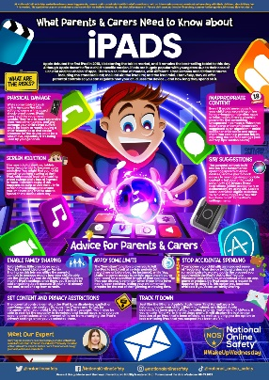
Thank you for your support,

Mrs Sarah Bell
Headteacher

