Vocabulary Properties of materials |  | Anglo Saxons – |  | All about the United Kingdon
Material | A physical substance that things can be made from | Origins | Germany, Denmark and the Netherlands.  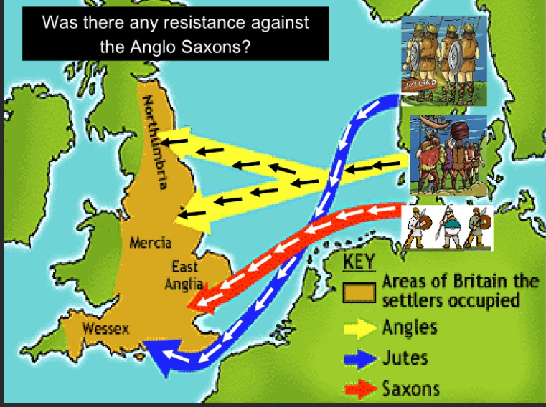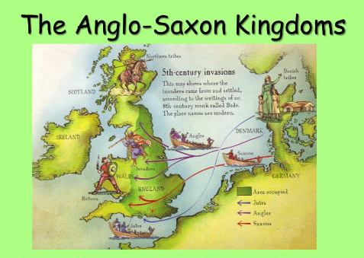 | Physical geography, | The study of the natural features of the earth's surface, especially in its current aspects, including land formations, climate.  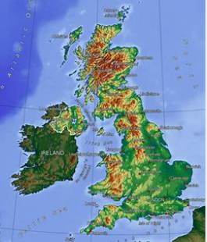
Properties | Property in the scientific field refers to a state of matter. For example, the property of water is that it is a liquid. The property of water vapor is that it is a gas. The property of ice is that it is a solid. | Sutton Hoo | Sutton Hoo is near the town of Woodbridge in Suffolk, England. The site was excavated in the 1930s and it has revealed some incredibly important finds and helped to further our knowledge of the Anglo-Saxons in Britain.  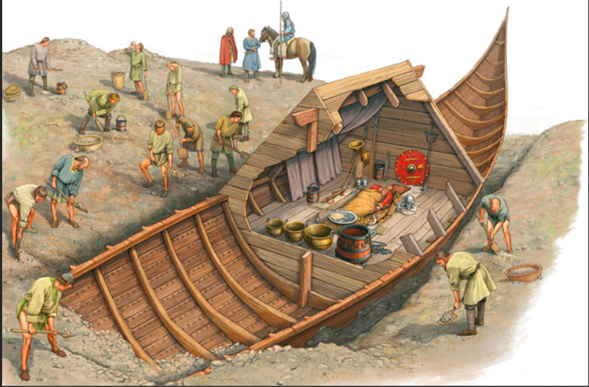 | Human geography | The study of the different ways in which human societies develop their physical environment.
Variables | Property in the scientific field refers to a state of matter. For example, the property of water is that it is a liquid. The property of water vapor is that it is a gas. The property of ice is that it is a solid. | Land form origins | Anglo-Saxon word Meaning Anglo-Saxon word Meaning  Ham Village Hurst Wooden hill  Stead/sted Place Ford Shallow river crossing  Mer/mar/mere Lake Leigh/lee/ley Forest clearing  Barrow Wood Bury Fortified place  Ton/tun Enclosed village or farmstead | Ordnance Survey symbols | Ordnance Survey maps use a range of symbol, abbreviations and language to communicate features on the landscape of Great Britain.  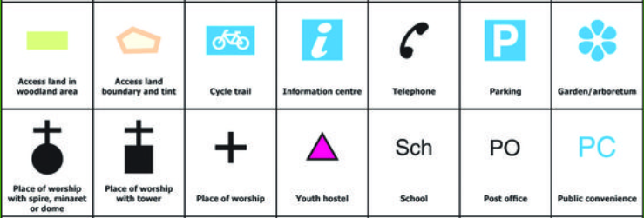
conductor | A material, which allows the transfer of thermal energy, is a thermal conductor or heat conductor. | What An Anglo Saxon Time line looks like?
transparency | Transparency is the quality of being easily seen through. | 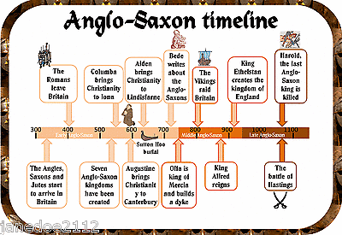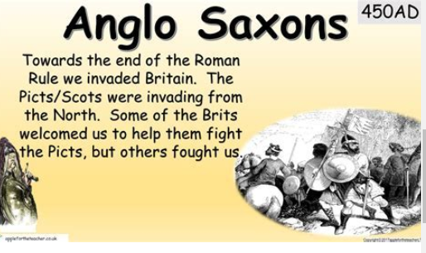
absorbency | n chemistry, absorption refers to the process through which one substance permeates another.

