Vocabulary Properties of materials |  | Design Technology  Where does our food come from? |  | Geography – Food, glorious food
Material | A physical substance that things can be made from | Design Technology | Research and evaluate exisiting food products to enable us to design and make a healthy and seasonal two course meal. | Geography | The food we eat comes from various and diverse places. Some food is produced locally but much of our has to be transported over many miles to reach us.
Properties | Property in the scientific field refers to a state of matter. For example, the property of water is that it is a liquid. The property of water vapor is that it is a gas. The property of ice is that it is a solid. | Where does our food come from? | 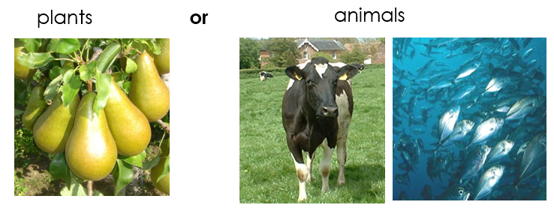 | Where does our food come from?  Which foods are natural or processed? | 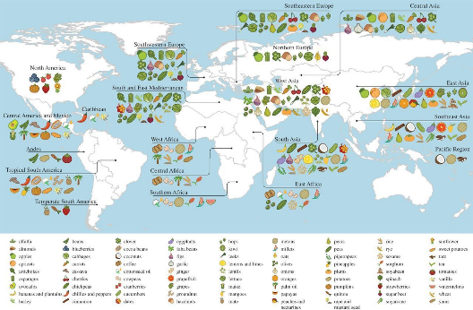
Variables | Property in the scientific field refers to a state of matter. For example, the property of water is that it is a liquid. The property of water vapor is that it is a gas. The property of ice is that it is a solid. | Seasonality | Understand seasonality, and know where and how a variety of ingredients are grown, reared, caught and processed  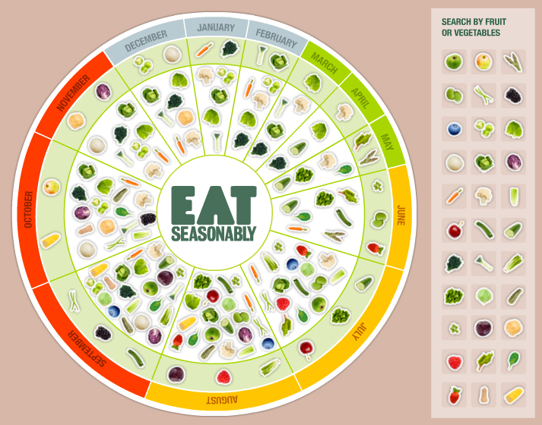 | How does the weather, climate and soil influence the type of food grown in the UK?  How does our food get to us and how many miles does it travel? | 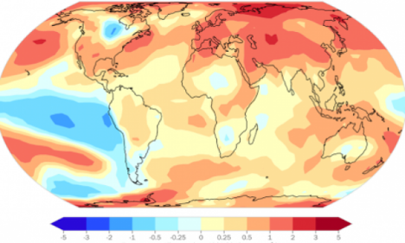  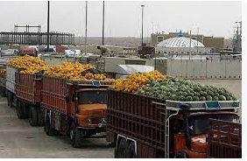  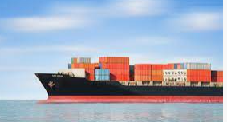
Liquid | A substance that flows freely but can be measured by volume e.g. water or oil | Science – Reversible and irreversible change  Art – Still life  What does evaporation look like? Which mixture is soluble? How can we separate a mixture?  What is irreversible change?
Irreversible | Cannot be reversed back to its original state. | 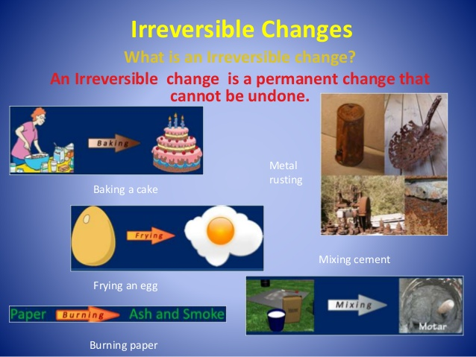  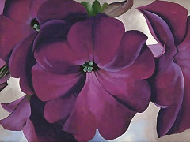  - Investigate using different drawing tools; grades of pencil, charcoal, chalk, graphite sticks, biros, pastels, oil pastels.  - Use dry media to make different marks, lines, patterns and shapes within a drawing.  - Children look at the work of still life painters such as Dutch masters, the Impressionists, Georgia O’Keefe.  - To make a serious of observational drawings of various still life arrangements of food, food bottles etc.  - Use ICT to change artwork.  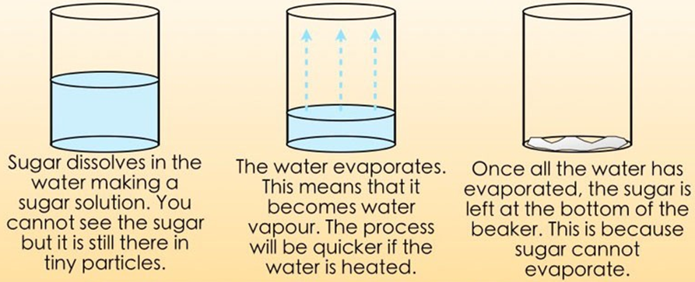  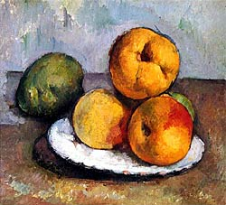
Reversible | Can be reversed back to its original state.
Evaporation | The process of turning from liquid to vapour.
Dissolve | When a substance mixed with the water to make a transparent (see-through) liquid called a solution.
Soluble | Able to be dissolved, especially in water.

