Year 4 Homework – Starling class and Kingfisher class
Date homework set: Thursday 12th October 2023
To be returned to school by: Tuesday 17th October 2023
Talking Topic (10 min)
With a friend or family member, discuss how we can show kindness at home and at school. Discuss what you would do if you saw somebody being mean to another person. We have been looking at hurtful behaviours in class and what we can do to show kindness to others.
Tick when you have completed this task.
Maths (10 min)
This year, Year 4 children will be taking part in the Multiplcation Maths Check. Therefore, we would like them to practice their times tables as much as possible so that they are confident when the check comes around.
Please use the link below to practice as it is a similar format to the one used during the formal check.
MTC Test - URBrainy
CHALLENGE!
We have been looking at additon and subtraction (Column Method)
Have a go at these:
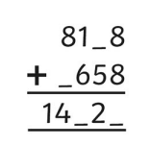
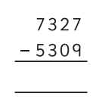
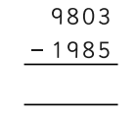
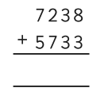
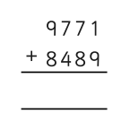

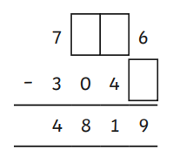

Tick when you have completed this task.

English (10 min)
Write a cinquain poem about a topic of your choice e.g. chocolate, dogs, family, the beach (We have made one in class about a firework)

Cinquain poems are five-line poems in which each line has a specific number of syllables. Words used in the poem can vary and include adjectives, action words, and feeling words. All cinquains follow the same pattern of syllables per line: 2, 4, 6, 8, 2.
Tick when you have completed this task.

Other tasks that could be completed;
. Practice Year 3/4 spellings.
. Times Tables Rockstar’s
. Purple Mash
. My Maths
. Read your reading book or Reading for Pleasure book.
. Complete the reading for pleasure book marks.
. Spag.com
. Bug Club

