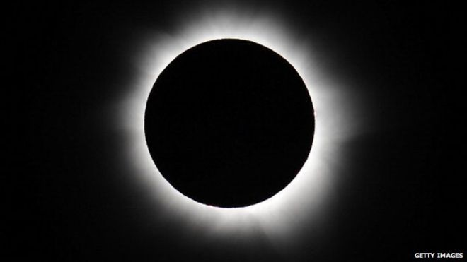
Solar eclipse 2015: What you need for a party next Friday

Next Friday we'll witness a solar eclipse, an event people once thought heralded the end of the world.
Fortunately the apocalypse is not yet upon us.
A solar eclipse is when the moon moves directly between the Sun and the Earth. It's unusual because the Earth, Sun and the Moon all have to align.
It also rare because of the elliptical (oval) shape of the Moon's path, or orbit, around the Earth, meaning the Moon is sometimes further away from us.
Additionally the Moon's orbit is on a tilt, making it even more rare when the Sun, Moon and Earth align.
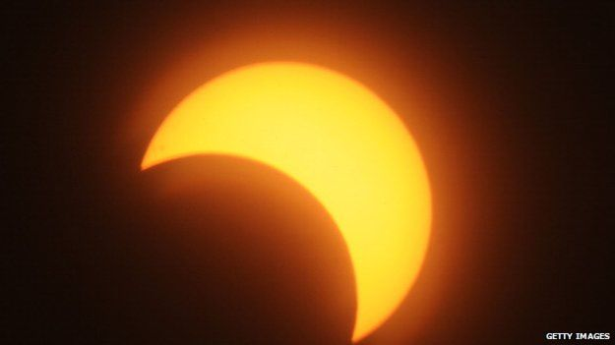
We haven't had a full solar eclipse since 1999 and the one happening this March is only a partial eclipse.
If you miss this one, it will be 2026 before you can catch the next partial eclipse.
It will be 2090 until the next total solar eclipse is seen in the UK.
As it's such an unusual occurrence, it's probably worth having a party.
Time: 8.45
It's going to be a breakfast affair as the eclipse begins in the UK at 8.45am.
The maximum eclipse, when the Moon is nearest the middle of the Sun, will be at 9.31am.
It will all wind down at 10.41am.
Place: A boat off the Faroe Islands OR anywhere with a clear view of the horizon
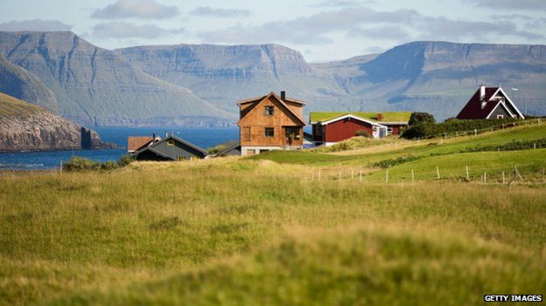
The further north you go, the greater the shadow over the Sun and the fuller the eclipse.
Up to 94% of the Sun's light will be blocked by the Moon in Scotland.
In places further south like London, the Sun will probably only be 85% obscured by the Moon.
According to Dr Edward Bloomer, an astronomer with the Royal Observatory in Greenwich, the Faroe Islands is the best place to see it.
The best place to see the eclipse is on the Faroe Islands, north of Scotland
But if you can't make it that far north, you'll still get a "very good view indeed" in the rest of the UK.
All you need is a "nice clear horizon and view of the sky".
It's about not having tall buildings or trees blocking the view.

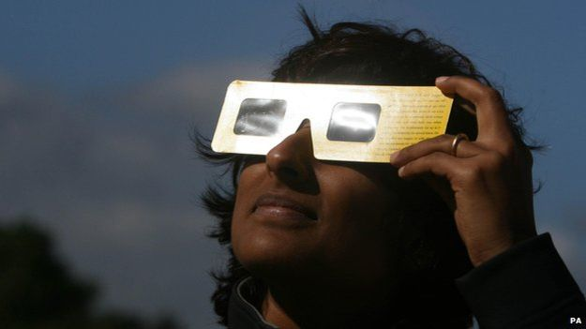
Bring your own...

Eclipse glasses: Looking at the Sun directly damages your eyes.
These special specs are specially made to filter out harmful radiation and ultra violet light so you can gaze at the star without hurting your vision.
People watch the eclipse of the Sun with filter glasses in London in 2009

They are relatively cheap and you can buy them online.
Alternatively Dr Bloomer says you can make your own eclipse viewer at home with a "pinhole projection".
He told Newsbeat: "Get yourself a piece of card and cut a hole in it.
"Cover that with a piece of tinfoil, pierce a very small hole in it.
"If you point that towards the Sun and project the light coming through the pinhole onto a piece of white cardboard or paper then you can view the Sun and view the Sun's projection there, so you aren't looking directly at the Sun."
Is it just a blocked out Sun? What's the big deal?
It's not just the fact that you get to see the "celestial mechanics at work" which makes eclipses interesting, according to Dr Bloomer.
You can see the atmosphere of the Sun, called the corona (yup, like the beer) during the eclipse.
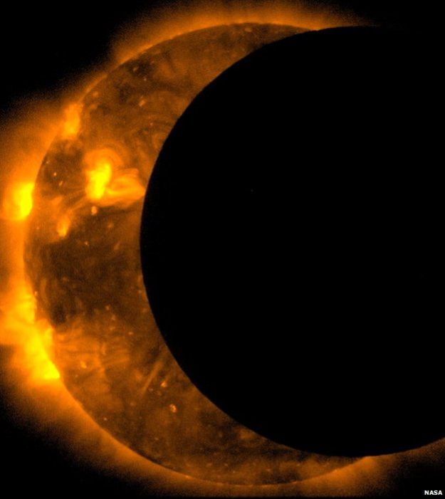
This corona is super-hot, 100 times hotter than the already impressive 5,538C temperature of the sun itself.
Eclipses reveal aspects of the corona, such as streamers, (long bright pointy bits packed full of electrons) plumes (thin streaks from the Sun's north and south pole), and loops (shimmering active magnetic fields, often found above darker sun spots).

Conversation starters
If you're staring at the sky but feeling underwhelmed, indulge your fellow party-goers with some of these eclipse-related facts to get the party started.
Sun spots can be seen as the Moon moves into a partial eclipse position

1. Academics have tried to uncover the exact date for the crucifixion of Christ using astronomical calculations.
They take as their starting point the theory that the darkness that clouded the sky on Good Friday, when Jesus was on the cross, was actually a partial eclipse.
2. Those glasses are important.
You don't want to end up like 19th century psychologist Gustav Fechner, who partially blinded himself while doing experiments which involved staring at the Sun through a coloured lens.
3. In Romanian folklore Vârcolacs are wolf-demons that eat the moon and the sun during eclipses. They are often classed as vampire-hybrids.
Greek mythology borrows this notion for their 'vrykolakas'. However, these undead creatures drink blood and swell up like drums.
Korean folklore also links dogs with eclipses, saying that solar eclipses occur because mythical dogs are trying to steal the sun.
4. Muslims conduct special prayers during the eclipse. In them they thank Allah for his control over the Sun and the Moon.
5. There's a recurring myth that pregnant women can't go outside during an eclipse. Astronomers from the Griffith Observatory in LA say they get dozens of calls about it when an eclipse happens, even though it seems irrational. But if one of your friends is pregnant, don't worry, you can invite them along to your party. This myth has no basis in fact.
6. The word eclipse comes from the Ancient Greek word ékleipsis, which means abandonment.
7. The speed of the Moon as it moves across the Sun is approximately 2,250 km (1,398 miles) per hour.
Happy viewing!

Solar eclipse 2015: What you need for a party next Friday

- What is the Corona? (AF2)
- Why do you think the word ‘eclipse’ is derived from the Ancient Greek word which means ‘abandonment’? (AF5)
- How hot is the corona? (AF3)
- The text suggests having an ‘eclipse party’. Why is it unlikely that many people will be doing this? (AF3)
- Which of the historical ‘conversation starters’ did you find most interesting and why? (AF7)
- Give the meaning of the word ‘apocalypse’ (AF5)
- Why might a city not be the best place to watch the eclipse from? (AF3)
- How do you know that in ancient times people did not understand how an eclipse happened? (AF7)
- How many years is it between the last and the next total solar eclipse in the UK? (AF3)

Solar eclipse 2015:

Level 2/3

- What is a ‘solar eclipse’? (AF2) When the moon moves directly between the sun and the earth
- After this one, how many years is it until the next partial eclipse in the UK? (AF3) 11 years
- Where is the best place to view the eclipse? (AF2) Faroe islands / further north / somewhere with a clear horizon
- What should you do to protect your eyes when looking at the sun during the eclipse? (AF2) wear eclipse glasses or make a pinhole projector
- What part of the sun can be seen during a solar eclipse? (AF2) the corona
- How do you know that people were once frightened of solar eclipses? (AF3) They thought it heralded the end of the world / apocalypse / ancient folklore
- Which number of the ‘conversation starters’ is important for your safety? (AF3) 2. Those glasses are important!
- What is meant by ‘elliptical’? (AF5) oval
- Which of the ‘conversation starters’ did you find most interesting and why? (AF7) pupils own opinion
- Why is some of the print in bold? (AF4) sub-headings

Solar eclipse 2015

Level 3/4

- When is the next total solar eclipse in the UK? (AF2) 2090
- How hot is the corona? (AF3) 5538°C (x100)
- At what time is the maximum eclipse? (AF2) 9:31am
- What is the total length in time of the solar eclipse? (AF3) 1 hour 56 miutes
- Why do you think that this is such a special event? (AF3) it doesn’t happen very often
- How do you know that people were once frightened of solar eclipses? (AF3) They thought it heralded the end of the world / apocalypse / ancient folklore
- What is meant by, ‘the Sun, Moon and Earth align’? (AF5) The Sun, Earth and Moon all lie in a straight line
- Which of the ‘conversation starters’ did you find most interesting and why? (AF7) pupil’s own opinion
- Why is some of the print in bold? (AF4) subheadings
- Draw a flow diagram, which shows how to make a pinhole camera. (AF4) A flow diagram using arrows to show the steps: cut hole in card, cover it with tin foil, pierce a small hole, point towards the sun, project the light coming through the pinhole onto a piece of card

Solar eclipse 2015

Level 4/5

- What is the Corona? (AF2) atmosphere of the sun
- Why do you think the word ‘eclipse’ is derived from the Ancient Greek word which means ‘abandonment’? (AF5) because the sun seems to disappear or abandon the Earth
- How hot is the corona? (AF3) 5538°C (x100)
- The text suggests having an ‘eclipse party’. Why is it unlikely that many people will be doing this? (AF3) Because people will be at work or school at this time of day
- Which of the historical ‘conversation starters’ did you find most interesting and why? (AF7) pupils own opinion
- Give the meaning of the word ‘apocalypse’ (AF5) the end of the world
- Why might a city not be the best place to watch the eclipse from? (AF3) building will obscure the horizon and block the view
- How do you know that in ancient times people did not understand how an eclipse happened? (AF7) there were myths and folklore surrounding the event / they thought it heralded the end of the earth
- How many years is it between the last and the next total solar eclipse in the UK? (AF3) 91 years (2090-1999)
- Draw a flow diagram, which shows how to make a pinhole camera. (AF4) A flow diagram using arrows to show the steps: cut hole in card, cover it with tin foil, pierce a small hole, point towards the sun, project the light coming through the pinhole onto a piece of card

Each week, during the English term time, we release a new reading comprehension resource on our website http://headwaylearning.co.uk

The resources all use topical texts such as news reports, frequently addressing Spiritual, Moral, Social and Cultural (SMSC) themes which are often hard to cover using traditional materials. Three differentiated sheets, each of 10 questions, are included from L2 – L5 allowing the resources to be used for all learners from able Y1, through KS2 and into KS3. Each question also has an AF reference for the English curriculum. To gain the maximum benefit, we recommend using resources with a context which is familiar to pupils. For resources using news reports this will frequently be soon after they are published as pupils will be aware of the context. The resources can of course be used at other times, particularly if they support a topic which is being followed across the curriculum.

Our research has shown that regular use of these resources enables pupils to make accelerated progress.

We offer these resources through our website both individually and as an annual subscription which enables schools access to all previous resources.

Feedback from a satisfied teacher:

“That is fantastic - you are quick off the mark! I really do love your reading comprehensions!
I try to share as many global topics with my children as possible and doing them as a reading comprehension means they get to practice this as well. I've just done a mock reading comprehension SAT with my Year 6s last week and most of them got Level 5 or high 4. I definitely think the Headway comprehensions have given them a boost!

Thank you
Jane”

