Year 1 Homework
Date homework set: Thursday 15th July 2021
To be returned to school by: Thursday 2nd September 2021

Summer Homework

Maths
Log on to Purple Mash.
Each week a new game will be set as a 2do for you to complete. Some of the games have different levels so choose the level you need to practise, or you can play all of the levels for extra practise!

Week 1 - Simple addition to 5/10/20
Week 2 - Number bonds to 5/10/20
Week 3 - Mixed form addition to 5/10/20
Week 4 - Addition and subtraction
Week 5 - Simple/mixed form subtraction to 20
Week 6 - Addition and subtraction

If you want some extra games to play, you could explore some other activities on Purple Mash or you could practise some of the number bonds levels on 'Hit the Button'. https://www.topmarks.co.uk/maths-games/hit-the-button

Tick when you have completed these tasks.
Reading
Log on to Bug Club to read some extra books.

Tick when you have completed this task.
Spelling
you the a do to today of said says are were was is his has I you your they be he me she we no go so by my here there where love come some one once ask friend school put push pull full house our
Tick when you have completed this task.

Writing
Here are links to our English learning on BBC bitesize. Each week click on one of the links and complete the activities.
Tick when you have completed this task.

Week 1:
Writing sentences - Year 1 - P2 - English - Home Learning with BBC Bitesize - BBC Bitesize
Week 2:
Using capital letters and full stops in sentences - Year 1 - P2 - English - Home Learning with BBC Bitesize - BBC Bitesize
Week 3:
Using 'and' as a joining word - Year 1 - P2 - English - Home Learning with BBC Bitesize - BBC Bitesize
Week 4:
Adding the prefix un- - Year 1 - P2 - English - Home learning with BBC Bitesize - BBC Bitesize
Week 5:
Using verbs - Year 1 - P2 - English - Home Learning with BBC Bitesize - BBC Bitesize
Week 6:
Adding the suffixes -ed and -ing - Y1 - P2 - English - Home learning with BBC Bitesize - BBC Bitesize

Project Homework

The Place Where I Live
Make a model of the street where you live and label the different things you have made. You could include things like - houses, roads, trees and grass.
You could use:
Lego or other construction toys
Recycling like cardboard boxes
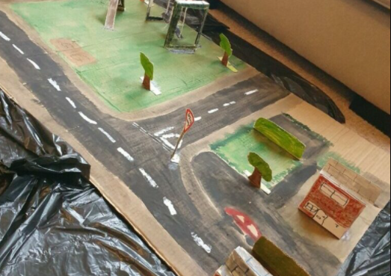
Don’t forget to take a photograph of your model to bring into school in September.

You should also have a copy of:
Practice phonics screening test
Letter formation sheets
Practice bronze award sheet that needs to be timed (3 minutes)
This sheet will be attached on our class page on the school website for you to easily access some of the links.

