Upper Reedley – Italy | Upper Reedley – Italy | Upper Reedley – Italy
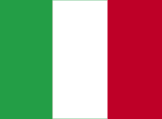  Make an Italian recipe.  Write a series of text messages between two characters.  Tell me five facts about Italy.  Research a special Italian building or landmark.  Draw a comic strip of key events from a story you enjoy.  Have you had a similar experience to a character? Write or draw about it and say why it was similar. | 