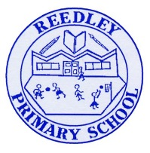
Year 4 Homework – Starling class and Kingfisher class
Date homework set: Thursday 11th January 2024
To be returned to school by: Tuesday 16th January 2024
Talking Topic (10 min)
Have a discussion with an adult or friend about this week’s assembly ‘Children’s Rights’. Can you remember what some of the rights are? Do you agree or disagree with them? Why do children have more rights than adults?

Tick when you have completed this task.
Maths (10 min)
This year, Year 4 children will be taking part in the Multiplcation Maths Check. Therefore, we would like them to practice their times tables as much as possible so that they are confident when the check comes around.
Please use the link below to practice as it is a similar format to the one used during the formal check.
https://urbrainy.com/mtc

This week we have been looking at Place Value. Have a go with these;

- Plot these numbers onto the number line

- Round these numbers to the nearest 1000

- 2679 B. 459 C. 4551 D. 987 E. 9764

English (10 mins)
We are now looking at stories with a dilemma and focussing on the book ‘The Mousehole Cat’.
Write a setting description to inform the reader of what Mousehole looks like. Try to include this vocabulary within your description, harbour, breakwaters, far end of England.

Tick when you have completed this task.

.
Other tasks that could be completed;
. Practice Year 3/4 spellings.
. Times Tables Rockstar’s
. Purple Mash
. My Maths
. Read your reading book or Reading for Pleasure book.
. Complete the reading for pleasure book marks.
. Spag.com
. Bug Club

