Year 4 Homework – Starling and Kingfisher
Date homework set: Thursday 16.01.24
To be returned to school by: Tuesday 21.01.24

Talking Topic (10 min)
Talk to a family member of a friend about our value this week which is ‘honesty’. What does it mean? Can you give any examples of a time you have been honest? (You don’t need to write them down)

Tick when you have completed this task.

Maths (10 min)
This year, Year 4 children will be taking part in the Multiplcation Maths Check. Therefore, we would like them to practice their times tables as much as possible so that they are confident when the check comes around.
Please use the link below to practice as it is a similar format to the one used during the formal check.
https://urbrainy.com/mtc
We have continued with Place Value this week – looking at what comes after a decimal point (tenths and hundredths) we have also been converting decimals to fractions.
Complete the following:
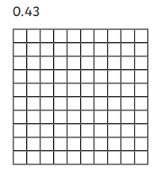
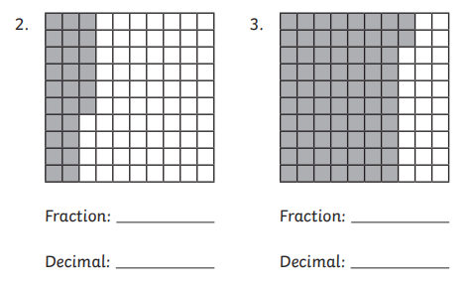

Can you shade in the correct boxes and write the answer as a decimal?

English (10 min)

Practise writing the Year 3 and 4 spellings words into your own sentences.

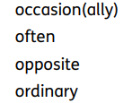
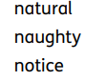
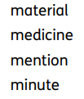

Tick when you have completed this task.

Other tasks that could be completed;
. Practice Year 3/4 spellings.
. Times Tables Rockstar’s
. Purple Mash
. My Maths
. Read your reading book or Reading for Pleasure book.
. Complete the reading for pleasure book marks.
. Spag.com
. Bug Club

