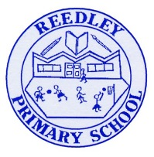
Year 5 Homework

Date homework set: 18.1.24
To be returned to school by: 23.1.24
When completing your homework try and do a little every day and not all at once.
Talking Topic
- Using this sentence,
- My Very Uneducated Mother Just Served us Noodles”, discuss the order of the planets in the solar system.
Tick when you have completed this task.
Maths Complete and learn the following;

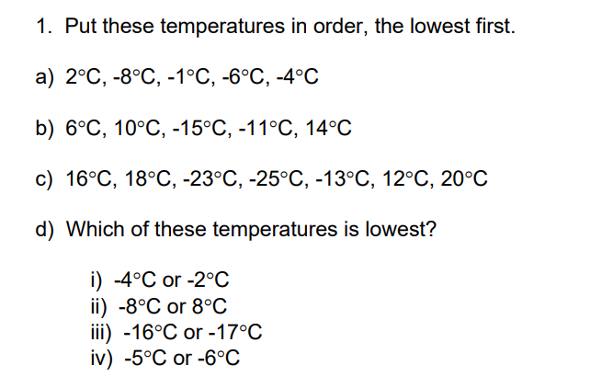

- Times tables Rock Stars.
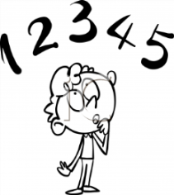
Tick when you have completed these tasks.
Reading
- Read the next chapter from your new reading for pleasure book.
- Read a book on Bug Club
- Continue with your next book mark.
- Read to an adult and ask them to sign your Reading Diary. Your reading diary will be checked.
Tick when you have completed this task.
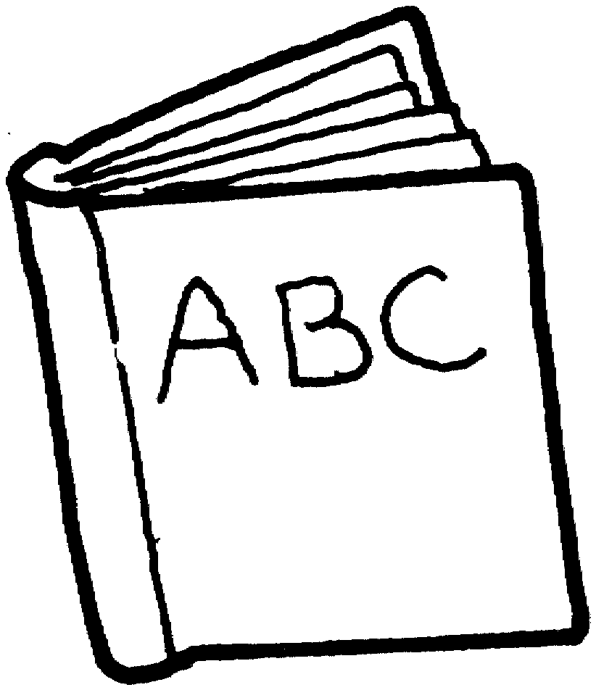
Spelling: Learn this week’s spellings and include each one in a sentence.
Occupy
Physical
Twelfth
exaggerate

Tick when you have completed this task.
Research: Choose another one of the planets from our solar system. Research it and write down at least 5 facts in your book. Include how long it takes to orbit the sun.
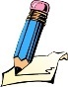
Tick when you have completed this task.

