How to Build a Snowman
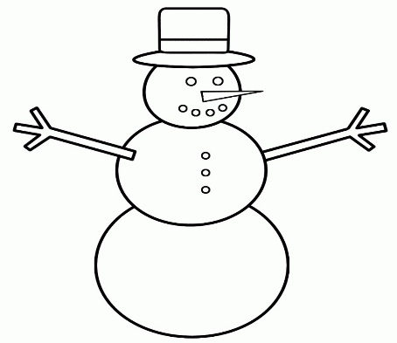
You will need:

Instructions:

