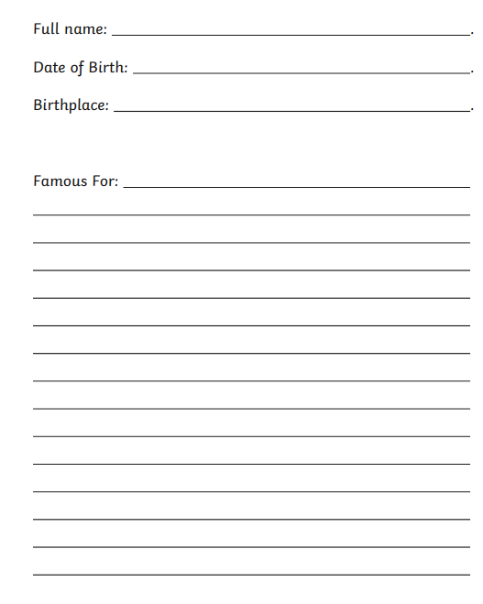
Dame Vera Lynn: Who was she and why was she important? - BBC Newsround
Vera Lynn - When The Lights Go On Again. - YouTube
HammerDex UK V7 VO2 (youtube.com)
Vera Lynn - We'll Meet Again (youtube.com)

