Year 5 Homework

Date homework set: 1.2.24
To be returned to school by: 6.2.24
When completing your homework try and do a little every day and not all at once.
Talking Topic
- Talk to an adult about how shadows are formed. Tell them about how the shadow’s length change over the course of the day
Tick when you have completed this task.
Reading
- Read the next chapter from your new reading for pleasure book.
- Read a book on Bug Club
- Continue with your next book mark.
- Read to an adult and ask them to sign your Reading Diary. Your reading diary will be checked.
Tick when
Spelling: Learn this week’s spellings and include each one in a sentence.
adorable
disposable
forgivable
enjoyable
identifiable
Tick when you have completed this task.
Maths
Complete and learn the following;
Learn the rules for divisibility.
Create a porter to show the facts
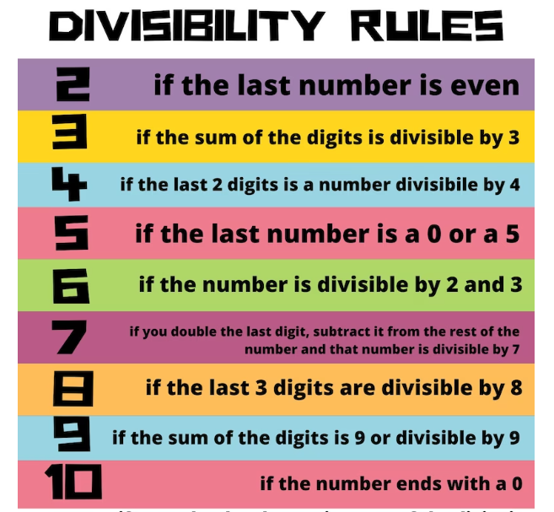
Complete Times tables Rock Stars.
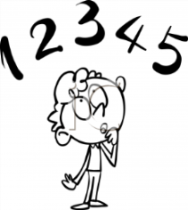
Tick when you have completed these tasks.
Research:
Using a time zone map, find out the time difference in New York, Sydney, Islamabd, Paris and South Africa
Tick when you have completed this task.

