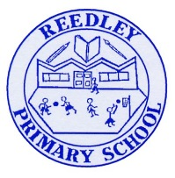
Year 5 Homework

Date homework set: 5.3.24
To be returned to school by: 12.3.24
hen completing your homework try and do a little every day and not all at once.
Talking Topic
- Talk to an adult about
- “The House of Wisdom and why it was important?
- Use these key words: library, scholars, 786AD, Mongols, Baghdad
- Tick when you have completed this task.
Reading
- Read the next chapter from your new reading for pleasure book.
- Read a book on Bug Club
- Continue with your next book mark.
- Read to an adult and ask them to sign your Reading Diary. Your reading diary will be checked.
Tick when
Spelling: Learn this week’s spellings and include each one in a sentence.
Hinderance
Necessary
Disastrous
Rhythm
Persuade
amateur

Tick when you have completed this task.
Maths
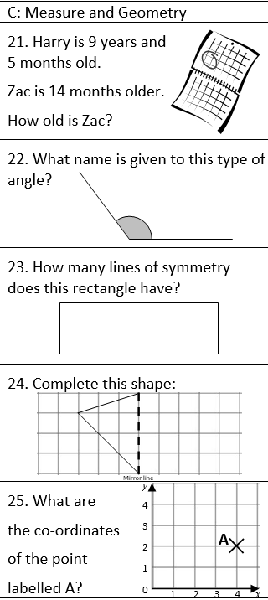
Complete Times tables Rock Stars.
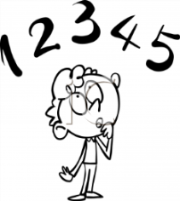
Tick when you have completed these tasks
Research:
Find out about Al Khwarizmi. Who was he? What did he do? What did he invent? Why was he an important figure?
Tick when you have completed this task.

