Friday, 19 April 2024
Dear Parents/Carers,

It was lovely to be back at school this week and to hear all the exciting stories from the school holidays. It sounds like children had a lot of fun during Eid including getting lots of money, new toys and new clothes!

E Safety Parent Session
Wednesday 24th April 7-8pm via Zoom
As a headteacher, and a parent, I feel increasingly concerned about the online world and the threats it can have for our children. We are running an online session to offer advice and support for parents/carers of ways that we can protect our children. Lindsay Vaughton will be running the session. She delivered a session in school in December, and it was exceptionally informative.
She will also be giving details of our Online Safety Hub and how you can use Qustodio to monitor your child’s online activity.
We will send out the link for the session next week, which will take place via Zoom.
I would urge you all to attend. The use of technology is changing rapidly and in order to keep our children safe, we need to be informed about the programmes/apps/software that they may have access to.

Attendance
Our overall attendance for this week is 91.26%.

These three classes achieved the 96%+ target this week:
Y3 Miss Veldon (98%), Y1 Mrs King (97%) and Y5 Mrs Malik (96%)

Punctuality
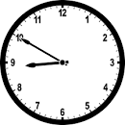
We had 8 hours and 10 minutes of lates this week, meaning vital learning is still being missed by some children. All children need to be in school by 8.50am each day.

These classes had no lates this week: Y5 Mrs Malik, Y4 Miss Radcliffe and Y1Mrs King.

Events This Week

- The children who achieved 96%+ for their attendance for the Spring Term took part in a treat on Monday. They watched a magic show from magician Taz.
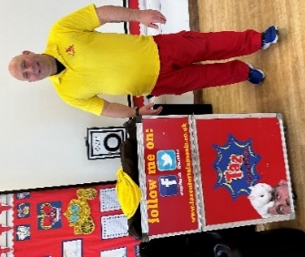
There will be another attendance treat for the children
who achieve 96%+ for the Summer Term
(from now to the end of the school year.)

- Award-winning author (and parent of a past pupil at Reedley)
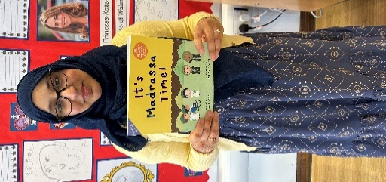
spoke to the children and shared information about her role
as an author.

- Year 3 children did their Eid assembly today. Thank you to the Y3 families that were able to attend. It was great to hear about the customs and traditions that families follow during Eid and the meaning behind them.

- Some Y1 parents attended an introduction to NumBots session on Wednesday, which is an online maths programme to support learning

- A group of Y5/6 boys attended a football match on Thursday (in the rain) at Pendle Vale, as part of the football league.

Upcoming Events

Parent Session Y4
Y4 parents are invited to attend a session to find out about the Y4 Multiplication Check and how to support their child
Y4 parents: Wednesday 24th April 9.00am-9.30am

Clubs
There are two clubs that take place on a Monday (girls’ football and homework). Children can be collected from the school office.

All other clubs are on a Wednesday. Please collect your children from the playground at 4.15pm.
All clubs will finish at half term.

Key Dates
- School will be closed on Thursday 2nd May and Monday 6th May.
- Y6 SATS tests take place week beginning 13th May.
- School closes for half term after school on Friday 24th May and reopens on Monday 3rd June.
- School will be closed for two days for Eid in June. We will announce these dates closer to the time, but it is likely to be either 17th and 18th June OR 18th and 19th June.
Thank you for your support,
Mrs Bell, Headteacher

