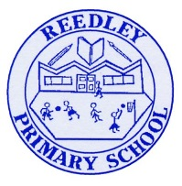
Year 4 Homework – Starling and Kingfisher
Date homework set: Thursday 25th April 2024
To be returned to school by: Tuesday 30th 2024

Talking Topic (10 min)
Talk to a friend or family member about ‘The Water Cycle’ which is something we have learned about in Science this week. Can you talk about evaporation and condensation.

Tick when you have completed this task.

Maths (10 min)
This year, Year 4 children will be taking part in the Multiplcation Maths Check. Therefore, we would like them to practice their times tables as much as possible so that they are confident when the check comes around.
Please use the link below to practice as it is a similar format to the one used during the formal check.
https://urbrainy.com/mtc
Purple Mash times table activities have been set but you can access these at any time.
We have been looking at quadrilaterals and other 2D shapes this week and their properties.
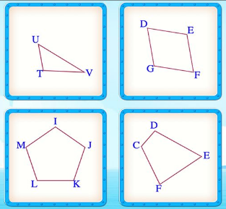
B
Av
In shapes A, B, C and D, can you work out their properties using the prompts below?
- What angles do they have? Acute, obtuse or right angles?
- Do they have any parallel lines?
- Do they have any perpendicular lines?
- Can you spot any lines of symmetry?
- How many diagonal lines can you find in each shape?
- Are they regular or irregular shapes?
- What are their shape names?

D
C

Tick when you have completed this task.

English (10 min)
Spelling practise - complete the crossword using ‘sc’ words that sound like ‘s’.
This has been printed out for you on a separate sheet
Tick when you have completed this task.

Other tasks that could be completed;
. Practice Year 3/4 spellings.
. Times Tables Rockstar’s
. Purple Mash
. My Maths
. Read your reading book or Reading for Pleasure book.
. Complete the reading for pleasure book marks.
. Spag.com
. Bug Club

