Year 4 Homework – Starlings and Kingfisher
Date homework set: Thursday 29th February
To be returned to school by: Tuesday 5th March

Talking Topic (10 min)
Talk to a friend or family member about these questions…
What are you proud of? Is there a time when you have shown pride in something? Provide some examples.

Tick when you have completed this task.

Maths (10 min)
This year, Year 4 children will be taking part in the Multiplcation Maths Check. Therefore, we would like them to practice their times tables as much as possible so that they are confident when the check comes around.
Please use the link below to practice as it is a similar format to the one used during the formal check.
https://urbrainy.com/mtc

Use the chunking method to work out the following;
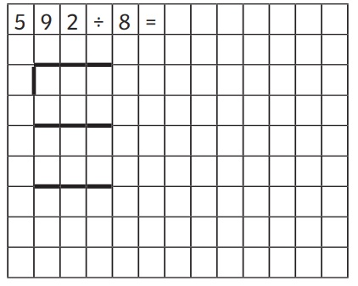
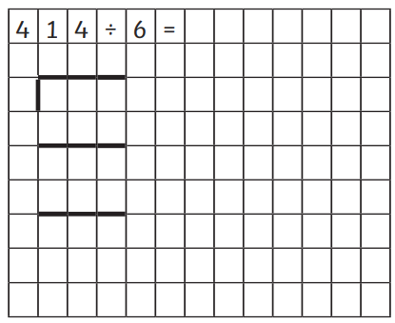

Challenge
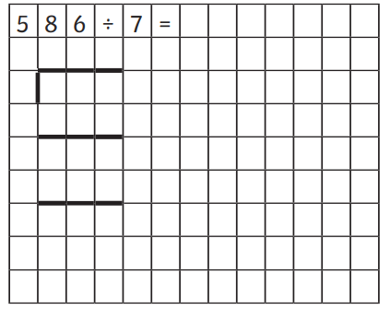

Tick when you have completed this task
English (10 min)
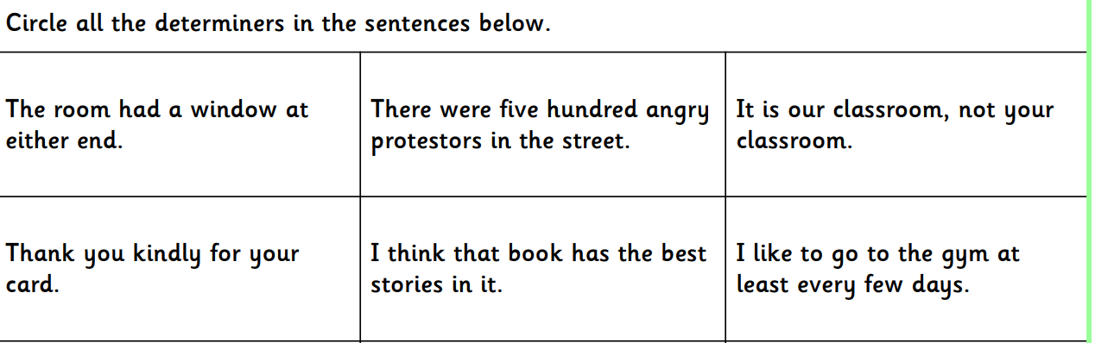

Tick when you have completed this task.

Other tasks that could be completed;
. Practice Year 3/4 spellings.
. Times Tables Rockstar’s Spag
. Read your reading book or Reading for Pleasure book. My Maths
.

