Year 4 Homework – Starlings and Kingfisher
Date homework set: Thursday 7th March
To be returned to school by: Tuesday 12th March

Talking Topic (10 min)
Talk to a friend or family member about this question…
If you could meet a character from a book, who would you choose? Why would you choose to meet them and what would you ask them?

Tick when you have completed this task.

Maths (10 min)
This year, Year 4 children will be taking part in the Multiplcation Maths Check. Therefore, we would like them to practice their times tables as much as possible so that they are confident when the check comes around.
Please use the link below to practice as it is a similar format to the one used during the formal check.
https://urbrainy.com/mtc

Tick when you have completed this task
English (10 min)

Create a mind map of everything you have learnt so far about climate change and the effects it has upon the world and animals e.g. the polar bear – we will use this as part of our explanation texts.

TIP - You might want to use a double page spread if you have a lot to write!
Example of mind map layout with headings;
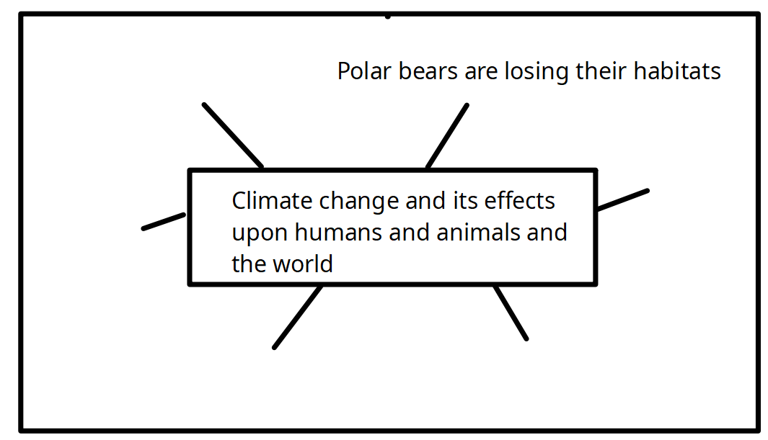

Tick when you have completed this task.

Other tasks that could be completed;
. Practice Year 3/4 spellings.
. Times Tables Rockstar’s Spag
. Read your reading book or Reading for Pleasure book. My Maths
.

