Vocabulary |  |  |  | Facts about Living things and their Habitats
Organism | An individual living thing, such as a plant, an animal, or a bacteria. | Habitat | The natural environment of an animal or plant. | The billions of different kinds of living things (organisms) on earth have been divided up, by scientists, into groups according to their similarities and differences. This is known as classifying.  • Classifying living things into groups allows scientists to learn more about what makes each species unique.  • There are many different classes of animal. Those with backbones are known as the ‘class’ vertebrates. These are then grouped into mammals, birds, fish, reptiles and amphibians. • Invertebrates, animals without backbones, are arachnids, insects, snails and slugs and worms.  • Humans fall into the mammal class as they have hair on their bodies and drink milk when they are babies. Whales, dolphins, bats, cats, dogs and hedgehogs are also mammals.  • A habitat is the non living environment surrounding a living thing. It provides space, shelter, food and water.  • An ecosystem is made up of the living organism and the non living habitat. An ecosystem can be any size from a tree to the whole world.  • Food chains are a map of the flow of energy from a plant (primary producer) through consumers, (primary consumers) and hunters Classifying Plants and Animals (secondary consumers).
 |  | Ecosystem | A community of living things, together with their environment.
Classifying | To put into groups according to things that are similar.
 |  | Food chain | A series of living beings in which each serves as food for the next.
Unique | - Being the only one of its type.
 |  | Energy | The ability to have force or power or to do work.
Vertebrate | Having a backbone
Invertebrate | Without a backbone. | 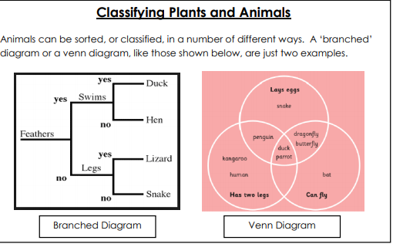
Mammal | - Any animal that has hair and feeds its babies with milk from the mother.
