Science
Vocabulary |  | 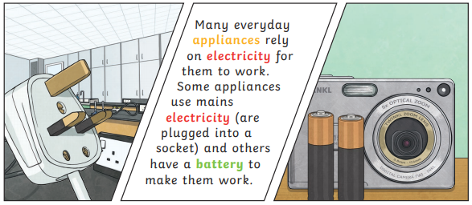  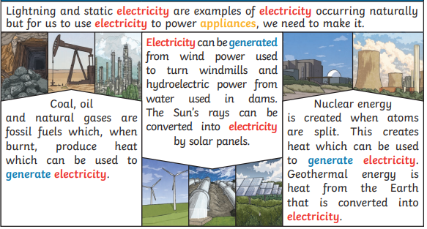
Electricity | The flow of an electric current through a material, e.g. from a power source through wires to an appliance.
Generate | To make or produce.
Renewable | A source of electricity that will not run out. These include solar, nuclear, geothermal, hydro and wind.
Non-renewable | This source of energy will eventually run out and so will no longer be able to be used to make electricity. These include fossil fuels – coal, oil and natural gas.
Appliances | A piece of equipment or a device designed to perform a particular job, such as a washing machine or mobile phone.
Battery | A device that stores electrical energy as a chemical.
Circuit | A pathway that electricity can flow around. It includes wires and a power supply and may include bulbs, switches or buzzers.

A conductor of electricity is a material that will allow electricity to flow through it. Metals are good conductors. Materials that are electrical insulators do not allow electricity to flow through them. Wood, plastic and glass are good insulators  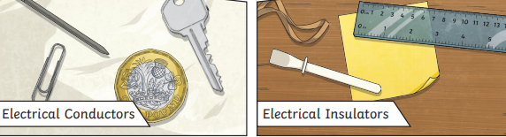 | 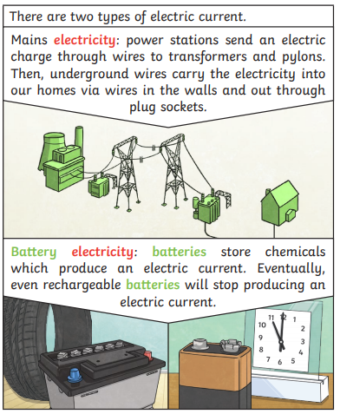
Switches can be used to open or close a circuit. When off, a switch ‘breaks’ the circuit to stop the flow of electricity. When on, a switch ‘completes’ the circuit and allows the electricity to flow
Electricity can only flow around a complete circuit that has no gaps. There must be wires connected to both the positive and negative end of the power supply/battery.

