Vocabulary Dozen |  | Healthy Humans |  | Animals including humans
healthy | in a good physical and mental condition |  | 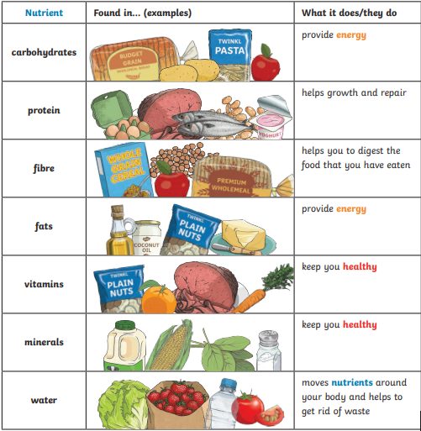 | 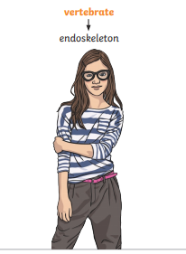  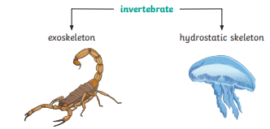
nutrients | substances that animals need to stay alive and healthy
energy | strength to be able to move and grow
saturated fats | types of fats, considered to be less healthy, that should
unsaturated fats | fats that give you energy, vitamins and minerals
vertebrate | animals with backbones
invertebrate | animals without backbones
muscles | soft tissues in the body that contract and relax to cause movement
tendons | cords that join muscles to bones
joints | areas where two or more bones are fitted together

