Find out about elephants. Draw and label a picture of an elephant.

Find out about elephants. Draw and label a picture of an elephant.

Find out about elephants. Draw and label a picture of an elephant.

Find an exciting WOW word in a book?.

Find an exciting WOW word in a book.

Find an exciting WOW word in a book.

Write a sentence about a book.

Write a sentence about a book.

Write a sentence about a book.

Answer this important question: **Can elephants jump?**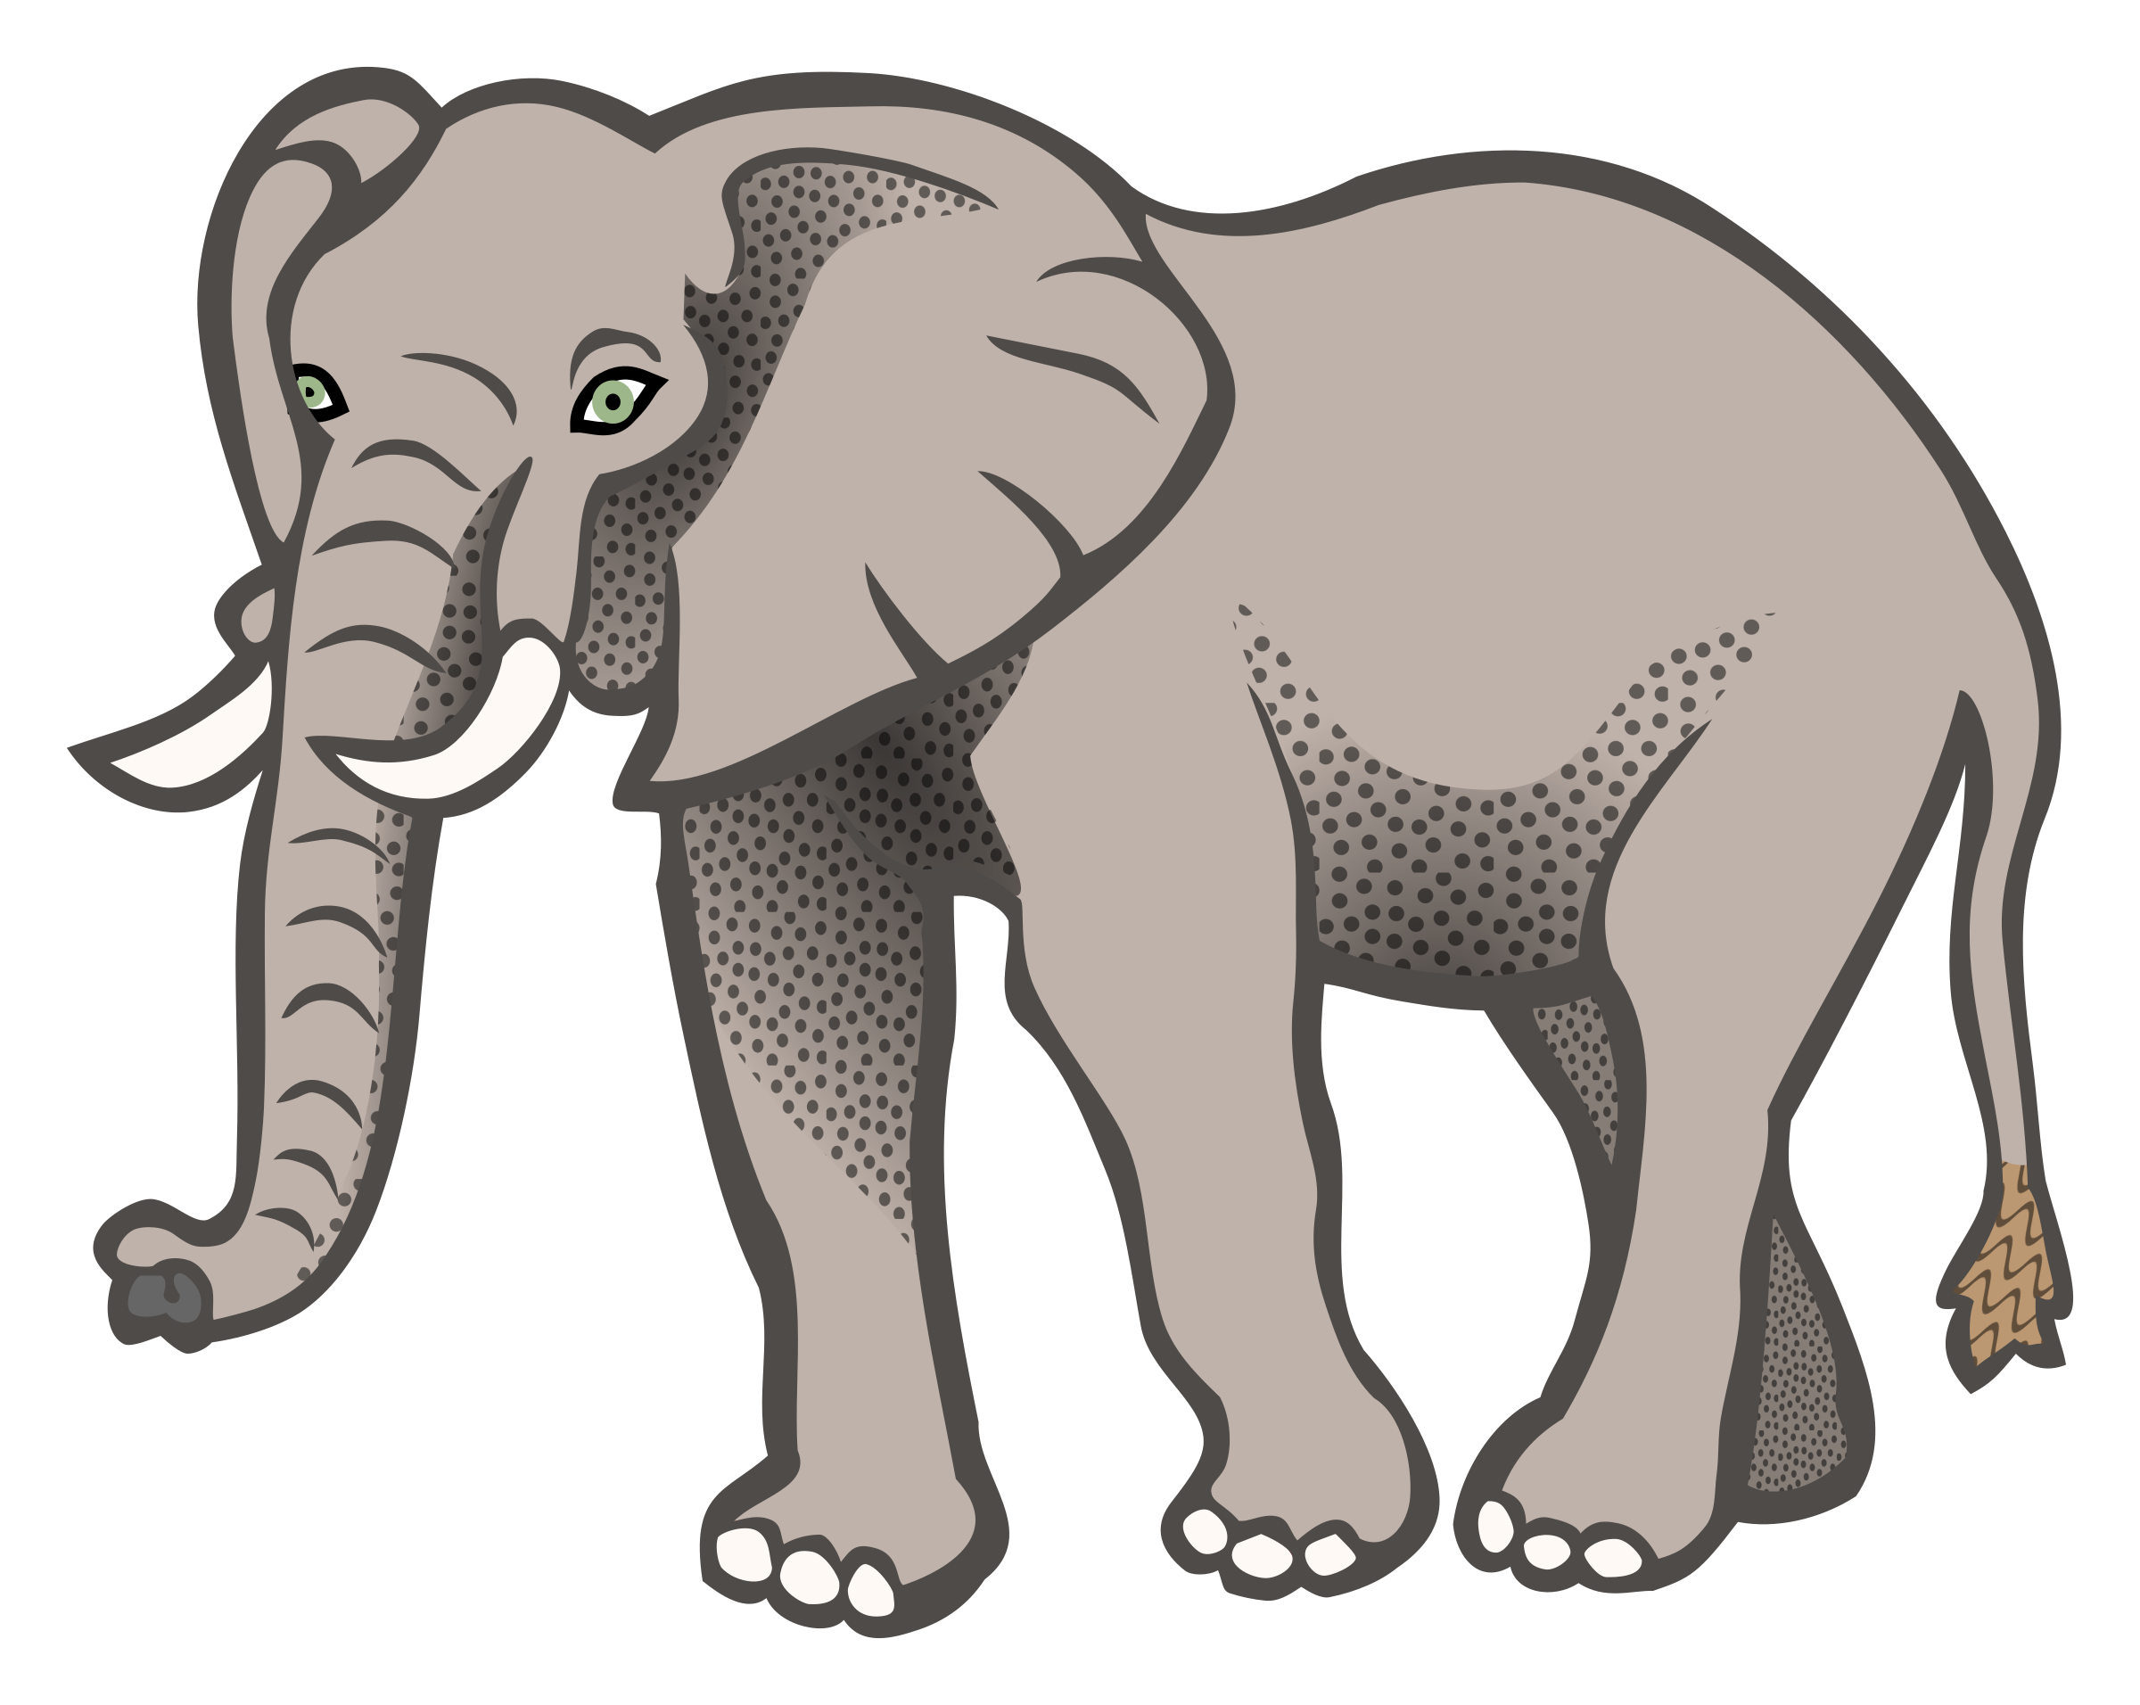

Answer this important question: **Can elephants jump?**

Answer this important question: **Can elephants jump?**

Read a book with the word ‘elephant’ in the title.

**Elephant** Lower Reedley

**Elephant** Lower Reedley

**Elephant** Lower Reedley

Read a book with the word ‘elephant’ in the title.

Read a book with the word ‘elephant’ in the title.

Write a speech bubble for a character.

Write a speech bubble for a character.

Write a speech bubble for a character.