**Firefly Lower**

Draw a new book cover for a favourite book.

Draw a new book cover for a favourite book.

Draw a new book cover for a favourite book.

Draw a favourite character’s bedroom.

Draw a favourite character’s bedroom.

Write a thought bubble for a naughty character.

Read an adventure story.

Read an adventure story.

Learn a fact about **fireflies** and share it with your class.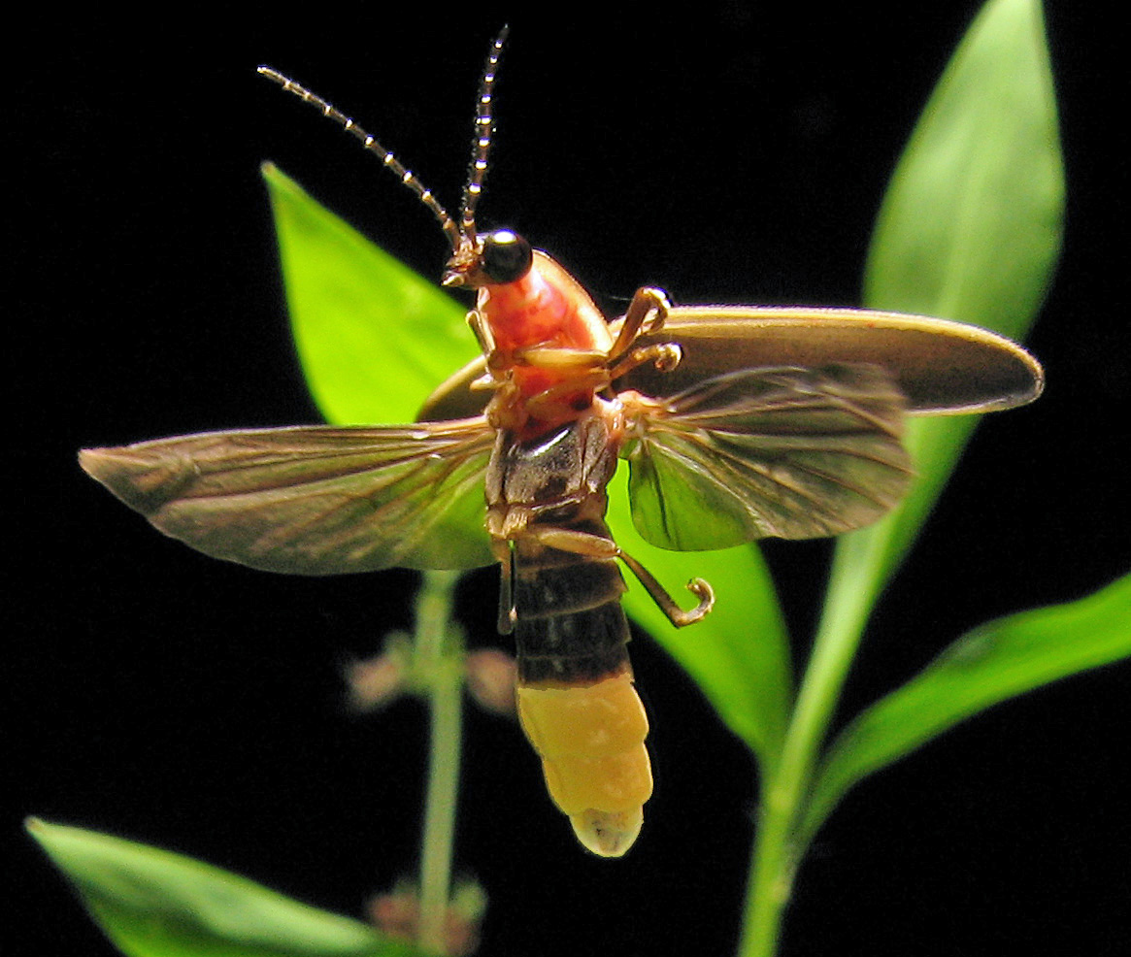

Read an adventure story.

Learn a fact about **fireflies** and share it with your class.

Draw a favourite character’s bedroom.

Learn a fact about **fireflies** and share it with your class.

Learn one verse of a favourite poem and perform it to your class or teacher.

Write a thought bubble for a naughty character.

Learn one verse of a favourite poem and perform it to your class or teacher.

Learn one verse of a favourite poem and perform it to your class or teacher.

Write a thought bubble for a naughty character.

**Firefly Lower**

**Firefly Lower**