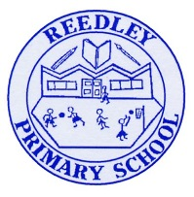
Year 5 Homework

Date homework set: 17.11.22
To be returned to school by: 22.11.22
Talking Topic (10 minutes)
- To discuss the following topic:
“Who were the famous mathematicians during Early Islam?”
Tick when you have completed this task.
Maths (10 minutes)
Complete the following:

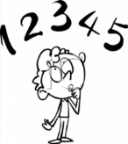
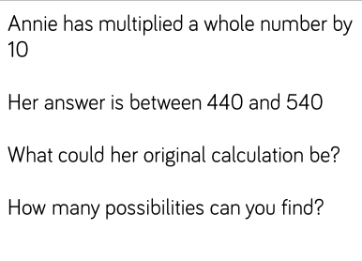

Tick when you have completed these tasks.
Writing (10 minutes)
Write a recount about your trip to Leighton Hall or research about Leighton Hall.

Spellings:
Learn these spellings:
Accommodate
Accompany
Achieve
Ancient
Bruise
Tick when you have completed this task.

