Upper Reedley – Barn Owl | Upper Reedley – Barn Owl | Upper Reedley – Barn Owl
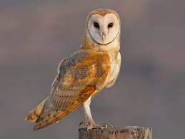  Read a non-fiction book. Share an interesting fact with your teacher.  Read a poetry book.  Draw a story map.  Find and describe a character you admire.  Learn the verse of a funny poem and perform it to a friend – with actions!  Write an unusual book review. | 