Year 6 Homework

Date homework set: 23.2.2023
To be returned to school by: 28.2.2023

Talking Topic To discuss the following topic:
What skills do you need to play badminton?
Tick when you have completed this task.
Maths
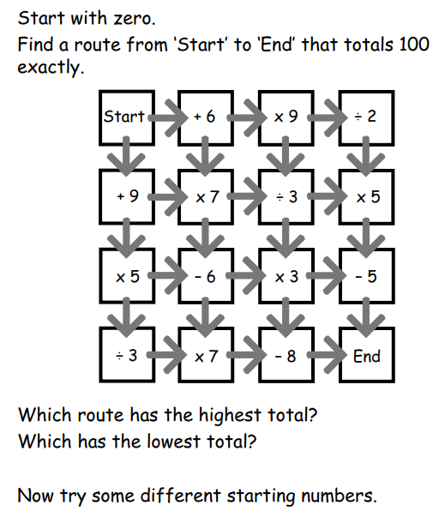
2. Complete My Maths activity
1.
English
Next Thursday is World Book Day. Your task is to learn a poem off by heart by Thursday. You can learn to recite any poem – funny, sad, topical. It can be a poem you have written, one from the sheet with this homework or one you have found in a book or online.
- Key Skill: learn a wider range of poetry by heart
Investigate four of the Year 5 and 6 spellings. Write them in interesting sentences in your homework book.
Further resources to practice your skills can be found on:
My Maths - MyMaths –
Spag.com- SPAG Tests Online -
Timestable Rockstart- Times Tables Rock Stars (ttrockstars.com)
correspond
criticise
curiosity
definite
desperate
determined
developed
dictionaries

