Year 6 Homework

Date homework set: 2.3.2023
To be returned to school by: 7.3.2023

Talking Topic To discuss the following topic:
If you were a character from a book, who would you be?
Tick when you have completed this task.
Maths
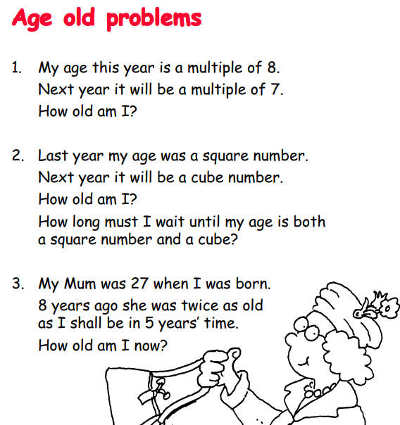
2. Complete My Maths activity
1.

English
In our English lessons we have been studying Shakespeare’s Romeo and Juliet. Your task is to write a character description for one of the characters – you can draw a picture as well as write a description about them. Describe their appearance, their personality and also include details about their friends and family (if you remember who they are)
- Key Skill: Use expanded noun phrases

Investigate four of the Year 5 and 6 spellings. Write them in interesting sentences in your homework book.
Further resources to practice your skills can be found on:
My Maths - MyMaths –
Spag.com- SPAG Tests Online -
Timestable Rockstart- Times Tables Rock Stars (ttrockstars.com)
language
leisure
lightning
marvellous
mischievous
muscle
necessary

