Question:

Think of your own question to ask about this picture:

____________________________________________________________________________________________________________________________________________________

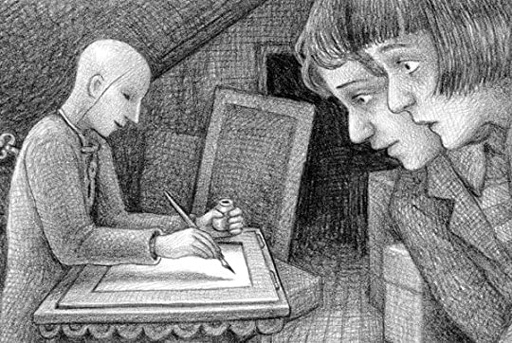

Explain what is happening in the picture.

____________________________________________________________________________________________________________________________________________________________________________________________________________________________________________________________

Inference question: Why do you think the children look shocked?

______________________________________________________________________________________________________________________________________________________________________________________________________________________________________________________________________________________________________________________________________________________________________________________________________________________________________________

Vocabulary: Think of 5 adjectives for this picture:

1)

2)

3)

4)

5)

Predict…

Write what might happen in the next 5 minutes:

________________________________________________________________________________________________________________________________________________________________________________________________________

Summarise

Give it a title:

______________________