Year 6 Homework

Date homework set: 9.3.23
To be returned to school by: 14.3.23

Talking Topic To discuss the following topic:
“Who was involved in the homefront?” Tick when you have completed this task.
Maths Complete and learn the following; and then complete Mymaths activity, ratio and proportion.
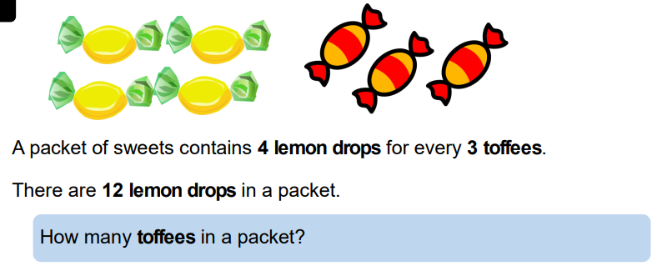

Writing
I want you to write a short story about what is going on in the picture. Use your imagination, making sure the main character is the leopard and include different types of sentences.
Key Skill: To include a semi- colon.
_______________________________________________________________
Investigate four of the Year 5 and 6 spelling. Write their meanings in your Homework books.
Different
Difference
Sincerely
Disastrous
equipped
Tick when you have completed this task.
Further resources to practice your skills can be found on;
My Maths - MyMaths – Ratio and Proportion.
Spag.com- SPAG Tests Online - Hyphens, dashes and bullet points
Timestable Rockstart- Times Tables Rock Stars (ttrockstars.com)

