Year 6 Homework

Date homework set: 16.3.23
To be returned to school by: .32123

Talking Topic To discuss the following topic:
“Why is there an motorway near where I live?” Tick when you have completed this task.
Maths Complete the question below and complete the Mymaths activity- map scales.
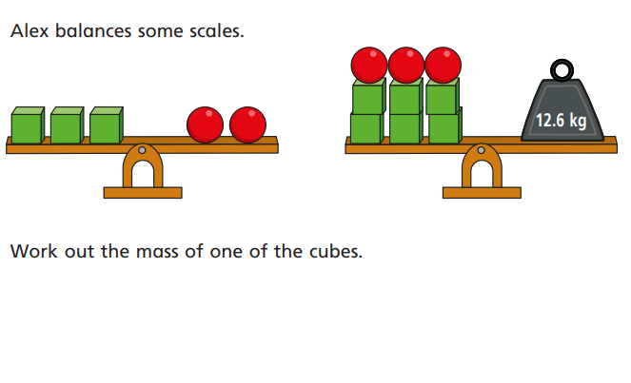
Writing
I want you to write a description of where you live? Think about the urban and aroble. This must be at least two paragraphs long.
Key Skill: To include a semi- colon and relative clause.
_______________________________________________________________
Investigate four of the Year 5 and 6 spelling. Write their meanings in your Homework books.
exaggerate
excellent
existence
explanation
familiar
Tick when you have completed this task.
Reading
Complete your reading for pleasure book mark and read atleast three time a week.
SPAG activity. This week’s activity on Spag.com is relative clauses.
Further resources to practice your skills can be found on;
My Maths - MyMaths – Ratio and Proportion.
Spag.com- SPAG Tests Online - Hyphens, dashes and bullet points
Timestable Rockstart- Times Tables Rock Stars (ttrockstars.com)

