Science vocabulary
Eyes | Globular organs of sight in the head of humans and vertebrate animals
Filter | Pass through a device to remove unwanted material (liquid, gas, light or sound)
Light | The natural agent that stimulates sight and makes things visible
Light Sources | Something that provides light, whether it be a natural or artifical source of light (e.g. the sun, a torch)
Periscope | An apparatus consisting of a tube of attached to a set of mirrors or prisms through which an observer can see things that are otherwise out of sight
Rainbow | An arch of colours visible in the sky, caused by the refraction and dispersion of the sun’s light by rain or other water droplets in the atmosphere
Reflection | The throwing back by a body or surface of light, heat or sound without absorbing it
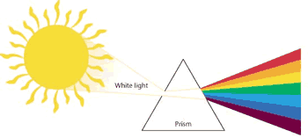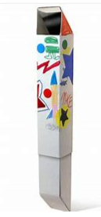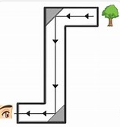
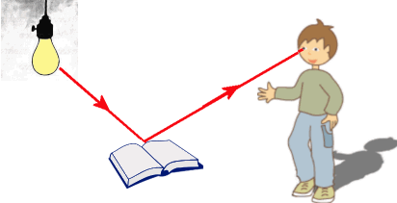
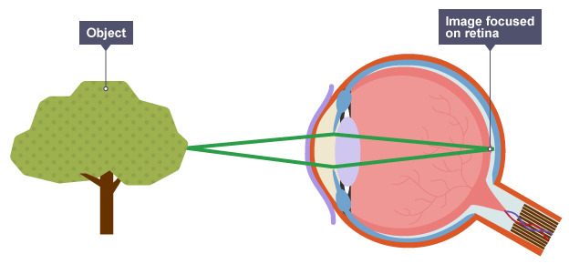
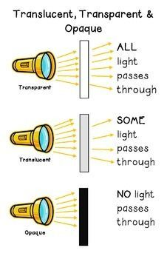
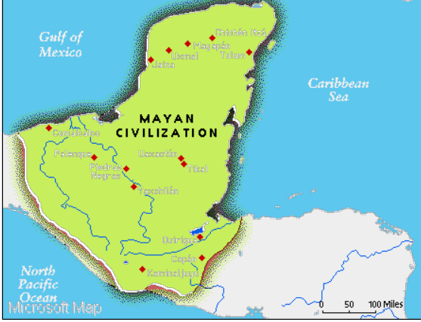
Healthy Eating
Nutrition | The act or process of nourishing or of being nourished; the use of food for life, health, and growth:
Gluten | The tough, viscid, nitrogenous substance remaining when the flour of wheat or other grain is washed to remove the starch.
Dairy | Relating to or for milk, cream, butter, cheese, etc.:
Intolerance | Abnormal sensitivity or allergy to a food.
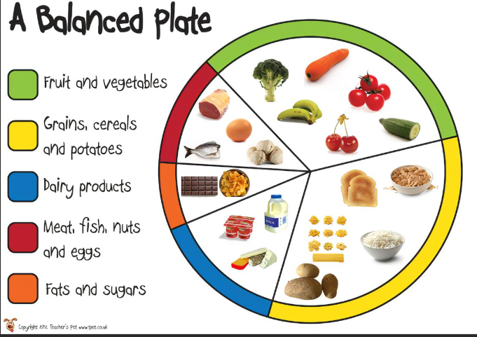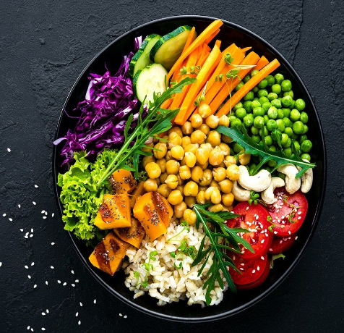
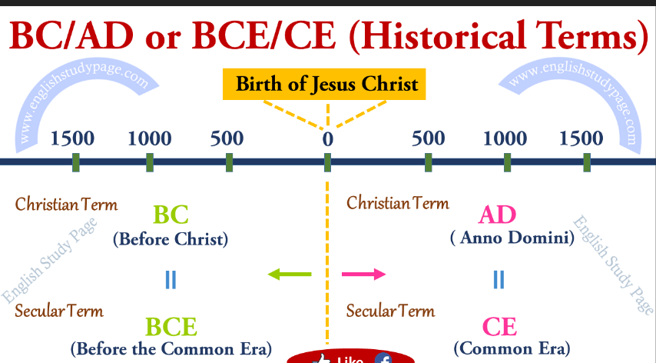
Key Vocabulary | Myans
cacao | A small tropical American evergreen tree, Theobroma cacao, cultivated for its seeds, the source of cocoa, chocolate,
Dynasty | A sequence of rulers from the same family, stock, or group:
Civilization | An advanced state of human society, in which a high level of culture, science, industry, and government has been reached.
Pyramids | A group of huge monuments in one of the Seven Wonders of the Ancient World. The pyramids have square bases and four triangular faces.

