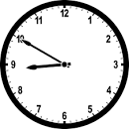
Monday, 24 April 2023
Dear Parents/Carers,

Eid Mubarak
I hope that all of our Muslim families had a wonderful Eid and I hope that you all enjoyed spending time with your families.

Attendance
Our overall attendance for last week was 93.19%.
This is still lower than our target of 96%.
The Willow Class (Y2S) had the highest attendance, with 97.09% for the week.

If your child is too unwell to come to school, please ensure that you call school to let us know the reason.
You can speak to us directly, or leave a message. Call the school number and press Option 1.

Punctuality
We had 5 hours and 25 minutes of lates last week, meaning vital learning is still being missed by some children. Well done to the Daffodil Class (Reception) who had no lates last week.
Please ensure that your child is in school before the gates closes at 8.50am each day.

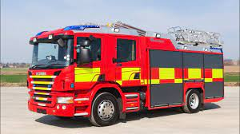
Events last Week
Children in Year 2 and Year 6 had a safety talk from the Fire Service.

Reading Award
Each half term teachers inform Mrs Gorrell about children in their class that carry out good quality pieces of work as part of their reading awards. Mrs Gorrell pulls out two of these names at random and the children each win a £10 book voucher.
This half term, the awards went to Abubakr Afzal in Y5 and Umaima Ihsaan in Reception.

Teacher Strike
There are two further teacher strikes that the NEU union have announced. These will be on Thursday 27th April and Tuesday 2nd May. On these days both Y3 classes and Y5M will be closed. Families of children in these classes have been informed about the closures and although there will be no taught lessons on these days I have again offered childcare places for these days.

Events this week
- Non-uniform day - We are asking the children to bring in donations of chocolate on Wednesday 26th April in preparation for the Eid Fair. In return the children can come in non-uniform on 26th April.

- Lunch - We are having an Eid lunch in school on Wednesday.

- Assembly - Year 3 have prepared an Eid assembly and will be delivering this for children in the school throughout the week. On Friday, the Year 3 parents are invited to come and watch at 9.15am.

Future Events
- Y6 children will be taking their SATS tests from Tuesday 9th May until Friday 12th May.
- Y2 children will be taking their SATS tests from Monday 15th May until Thursday 18th May.
- Y1 children will be taking their Phonics Screening Check between Monday 12th June and Friday 16th June.
- Y4 children will be taking part in the Multiplication Check between Monday 5th June and Friday 16th June.
The children must be present in school for this period of time.

- We are having an Eid Fair after school on Wednesday 3rd May from 3.45 – 4.45pm.

Please note that school will be closed on the following days:
- Monday 1st May - Bank holiday
- Thursday 4th May - School is closed as it is being used as a polling station
- Monday 8th May – Bank holiday for the King’s Coronation

Thank you for your support,

Mrs Sarah Bell
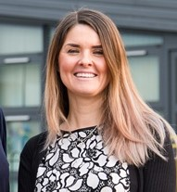
Headteacher

