Roll and Spell
This Photo by Unknown Author is licensed under CC BY-SA | 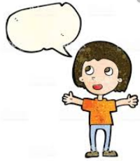  Say your word.
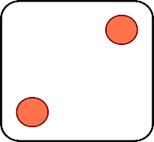  This Photo by Unknown Author is licensed under CC BY-SA | Rainbow write your word.
This Photo by Unknown Author is licensed under CC BY-SA | Write your word 3 times.  1 2 3
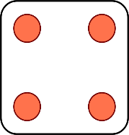  This Photo by Unknown Author is licensed under CC BY-SA | Write your word big.
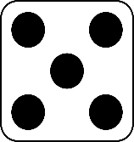 | Write your word small.
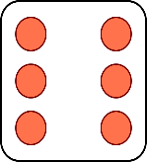  This Photo by Unknown Author is licensed under CC BY-SA | Write your word in a pattern.

Roll and Spell
This Photo by Unknown Author is licensed under CC BY-SA | Say your word.
This Photo by Unknown Author is licensed under CC BY-SA | Rainbow write your word.
This Photo by Unknown Author is licensed under CC BY-SA | Write your word 3 times.  1 2 3
This Photo by Unknown Author is licensed under CC BY-SA | Write your word big.
 | Write your word small.
This Photo by Unknown Author is licensed under CC BY-SA | Write your word in a pattern.
9

