Year 5 Homework

Date homework set: 28.9.23
To be returned to school by: 03.10.23

Talking Topic
- To discuss the following topic:
“Can you name the countries of Great Britain?”

Tick when you have completed this task.
Maths Complete and learn the following;
- On My Maths, complete Year 5 – addition and subtraction. Make sure you do the practise activity first.
- Times tables Rock Stars.
Tick when you have completed these tasks.
Reading
- Read the next chapter from your new reading for pleasure book.
- Read a book on Bug Club
- Continue with your next book mark.
- Read to an adult and ask them to sign your Reading Diary.
Tick when you have completed this task.

Spelling
Learn this week’s spellings.
reversible
curable
debatable
comfortable
available
controversy
Tick when you have completed this task.
Spag. Complete the SPAG.com activity.
Complete the activity below.
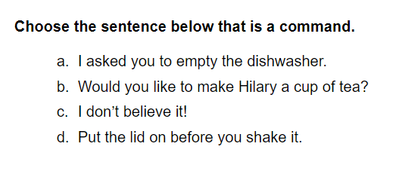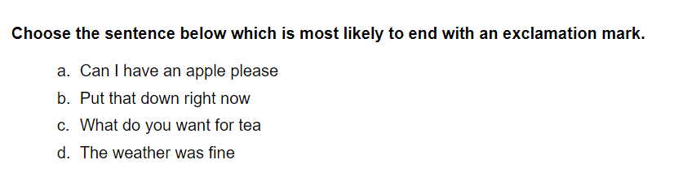

Writing
Write two paragraphs describing a character from a legend.
Key Skill: Subordinate clause and noun phrases.
Tick when you have completed this task.

