Year 5 Homework
Date homework set: 4.10.23
To be returned to school by: 10.10.23
Talking Topic
- To discuss the following topic:
“Why are friends special?”
Tick when you have completed this task.
Maths : Complete the task below.
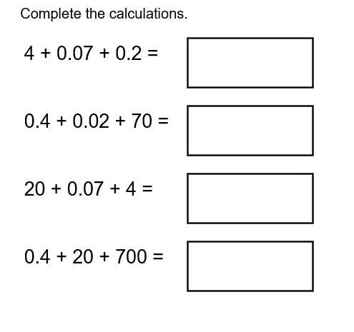
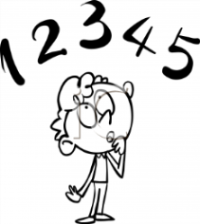
Tick when you have completed these tasks.
Reading
- Read the next chapter from your new reading for pleasure book. Ask someone to listen to you read.
- Complete your next bookmark.
Tick when you have completed this task.
Spelling : Learn this week’s spellings. Include them in a sentence.
Excited ,
Drenched, Confused,
Devastated, Aggressive
Tick when you have completed this task.
Spag. Complete the activity on SPAG. Com. Direct speech. https://www.spag.com
Writing. Imagine you are walking around the school field, write two paragraphs describing the school field. What do you see and hear.
Key Skill: Expanded noun phrases.
Reminder:
If you would like extra homework there are more activities on:
Times Tables Rock Stars – Times Tables Rock Stars (ttrockstars.com)
ActiveLearn: Login (activelearnprimary.co.uk) (Bug club)
https://whizz.com/

