Monday, 16 October 2023
Dear Parents/Carers,
Punctuality
We had 6 hours 15 minutes of lates this week, meaning vital learning is still being missed by some children. This seems to be increasing each week.
Please ensure that your child is in school before the gates closes at 8.50am each day.

Attendance
Our overall attendance for this week is 92.53%. This is the lowest that we have had all term and is significantly below our target of 96%.
The classes with the best attendance this week are:
Squirrels Y1K with 98.15%
Golden Eagles Y3H with 97.41%
Woodpeckers Y2C with 97.24%
Kingfishers Y4R with 96.55%

Other classes have attendance as low as 81%.

Events This Week
- Y3 children had a visit from Morris Dancers and all got the opportunity to take part themselves as part of their PE lesson
- Some Y5/6 girls took part in a football tournament
- Some Y5 children took part in a multi-skills event in Colne

Upcoming Events
- Year 4 children will be going on a trip to Astley Hall on Tuesday.

Parent/carer meetings
Parents/carers are invited to make an appointment to meet their child’s class teacher. Please make your appointment time before the end of the day on Monday 16th October if you have not done so already.

Calculation Policy in Maths
We have revised our calculation policies for maths. This includes written calculation and mental strategies and is broken down for each year group, starting from Reception (EYFS) and going up to Year 6. It shows the methods that we use for teaching maths throughout school. It would be useful for families to be aware of these strategies when supporting children with their maths work.
Please see your child’s class website page for the procedures, which are separated into the four different calculations addition, subtraction, multiplication and division.

Here is an example of part of the multiplication procedure
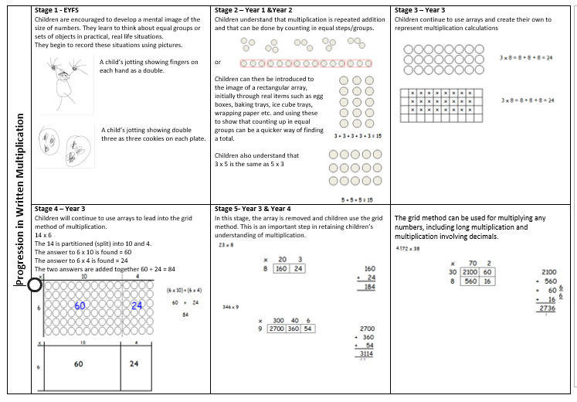

Clubs
Next week will be the last week of the current clubs. Letters have been sent out this week for the new clubs that will start after half term. Please ensure that you have returned any letters to school. You will be informed if you child has been given a place in a club.

Key Dates
- School will be closed for half term from Monday 23rd October to Friday 27th October.

Thank you for your support,
Mrs Sarah Bell
Headteacher

